EchoCal Complete Documentation



Joseph Godlewski

Michael Ryan

Marinna Martini

NOAA National Marine Fisheries Service, Woods Hole, MA

# Revision History

2021, February: R/V Armstrong Calibration, EchoCal-SOP_Feb_2021.docx

2021, March: add lessons learned from the F/V Henry Bigelow calibration, EchoCal-SOP_20210312.docx, and combine all documentation into one file.

# Description

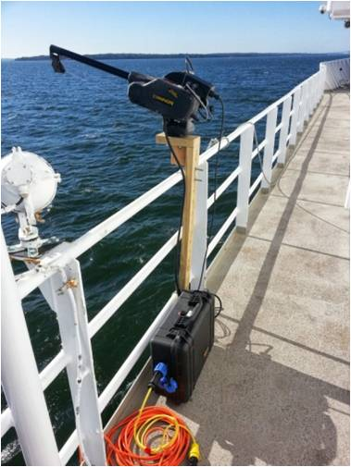

This document combines the EchoCal standard operating procedure, software installation and build, firmware installation, wireless setup, troubleshooting and other information into one comprehensive source of information for EchoCal. The first part of the document is the standard operating procedure. The rest of the reference information is in the appendices, which are the majority of this document. The standard operating procedure provides the routine details on preparing and operating the *EchoCal* system to calibrate acoustic sonar equipment on research vessels. *F/V Henry Bigelow* specific information is in red. Calibration is performed to maintain the accuracy of the data for scientific applications and is generally recommended when the ship has undergone a yard period or moves to an operating area with substantially different water mass properties.

These procedures, and EchoCAL itself, are designed to follow calibration practices as outlined in (Foote 1987), (MacLennan and Svellingen 1989) and (Foote 1984).

This comprehensive outline is for the latest version of the software, EchoCal version 1.2.0., available at https://github.com/MMartini1/PEMAD-ESB-EchoCAL

# List of figures

Figure 1: Pelican case encasing a downrigger station. The red box highlights where the serial number is located on the case. 6

Figure 2: Propeller and XBee electronics boards. The red box highlights that XBee board that can come loose in transit. 6

Figure 3: Internal of EchoCal control box. The red boxes highlight the location of the breakers that should be in the “on” position. 7

Figure 4: Rotate the monofilament attached to the downriggers to check if the encoders are working on the station. An LED light should display red when pulling one way, and display green the other way. 7

Figure 5: Serial Port Configuration interface. 9

Figure 6: Vessel configuration interface 10

Figure 7: Coordinate counts table 12

Figure 8: Sphere navigation interface. 13

Figure 9: Automated pattern interface. 14

Figure 10: Coordinate display window. 25

Figure 11: Top view of vessel measurement layout. 27

Figure 12: Side view of vessel measurement layout. 28

Figure 13: Vessel configuration tool. 29

Figure 14: Serial port configuration window. 30

Figure 15: Navigation control window. 31

Figure 16: Vessel diagram window. 34

Figure 17: EchoCAL Graphical User Interface (GUI) 35

Figure 18: EchoCAL GitHub Site: /bin/Win64 Folder 36

Figure 19: Download "echocal.zip" file from GitHub. 37

Figure 20. Unzipped EchoCAL folder. 37

Figure 21: EchoCAL Bin folder. 38

Figure 22: EchoCAL main GitHub project folder. 39

Figure 23: “EchoCalCustomFiles” folder contents. 40

Figure 24: "RXTXWin64" folder contents. 40

Figure 25: Local JAVA JDK folder for rxtxSerial.dll file. 41

Figure 26: Local JAVA JDK folder for RXTXcomm.jar file. 41

Figure 27: Open Project menu item. 42

Figure 28: Open Project Dialog Box. 42

Figure 29: EchoCAL Project Main Window. 43

Figure 30: Packaging EchoCAL as a ZIP distribution. 44

Figure 31: Java Development Kit (JDK) Folder. 45

Figure 32: ZIP Distribution Folder for EchoCAL. 45

Figure 33: New JRE folder inside "echocal.zip" file. 46

Figure 34: JInput Dynamic Link Libraries. 47

Figure 35: DLLs copied to ZIP distribution folder. 48

Figure 36: XCTU main window. 49

Figure 37: Discovery radio devices window. 50

Figure 38: Discovering radio modules window. 50

Figure 39: Radio configuration. 51

Figure 40: Discover remote devices window. 52

Figure 41: Wireless network display. 53

Figure 42: AP mode setting. 54

Figure 43: EchoCAL control box assembly. 56

Figure 44: PCB Serial Header Location. 57

Figure 45: Control box firmware source file selection. 58

Figure 46: Compiling and uploading control box firmware. 59

Figure 47: Accessing the microcontroller programming menu. 60

Figure 48: Entering a new control box serial number. 61

Figure 49: Exiting the programming menu. 62

# Equipment Setup:

## Downrigger Setup.

Each downrigger station, specifically the control box, has a unique serial number, which is labeled on the exterior of the pelican case (Figure 1). This serial number is used by the software to control the downrigger, and so it is useful to assign a logical order for the locations of each downrigger. For example, Station 1: STBD FWD, Station 2: PORT MID, Station 3: STBD AFT. Make sure you record which serial number control box is at each downrigger position (Table 1.) For example: Control Box EK60C001 is at the STBD FWD downrigger position.

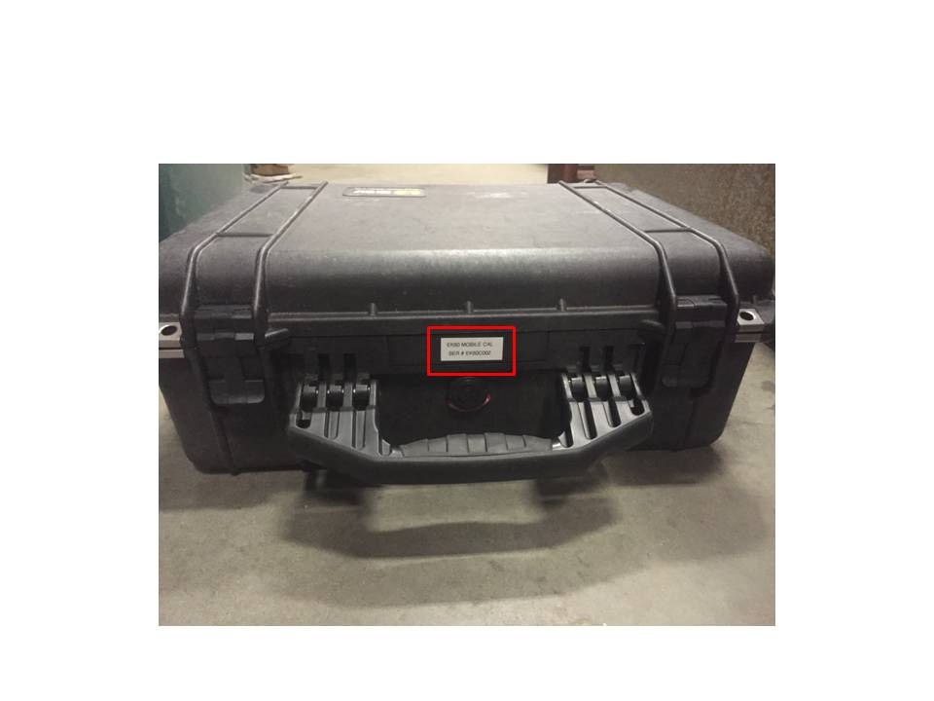

Figure 1: Pelican case encasing a downrigger station. The red box highlights where the serial number is located on the case.

### Check the XBEE antennae

Check to see if the XBEE antennae are seated properly and securely seated in the connectors on the electronics board below. With the power to the control box unplugged, press gently on the XBee board, highlighted in the red square (Figure 2).

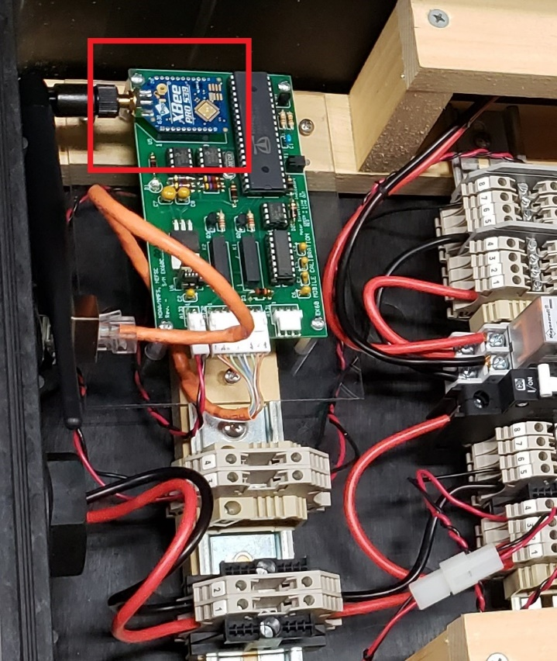

Figure 2: Propeller and XBee electronics boards. The red box highlights that XBee board that can come loose in transit.

### Check that each downrigger station has power:

When you plug in each station’s control box to a power source, a red light should illuminate on the outside of each pelican case**.** If the light does not illuminate, check to see if the circuit breakers on the inside of the control box are tripped**.** There should be 3 circuit breakers in the “on” position (Figure 3).

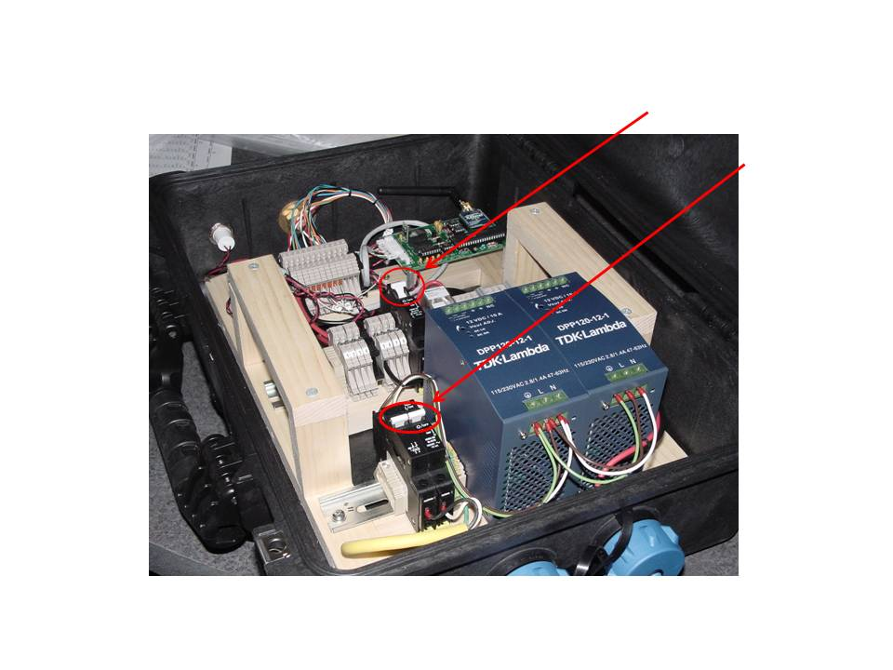

Figure 3: Internal of EchoCal control box. The red boxes highlight the location of the breakers that should be in the “on” position.

### Check that the downrigger spool rotates:

1. With power applied to the control box, release the clutch on the downrigger**.**
2. Using the toggle switch on the downrigger, briefly test the motor to make sure it will rotate in both directions**.**

### Check that the encoders are functioning:

1. To verify that the encoders on the downriggers are functioning, release the clutch on the downrigger**.**
2. Rotate the monofilament wheel to let out some monofilament line**.** The LED light on the control box’s circuit card should turn RED**.**
3. Rotate the monofilament wheel in the opposite direction, and this LED should turn GREEN (Figure 4)**.**
4. If this does not happen, make sure all connections are secure**.** Disconnect and reconnect the waterproof RJ45 connector on the downrigger.

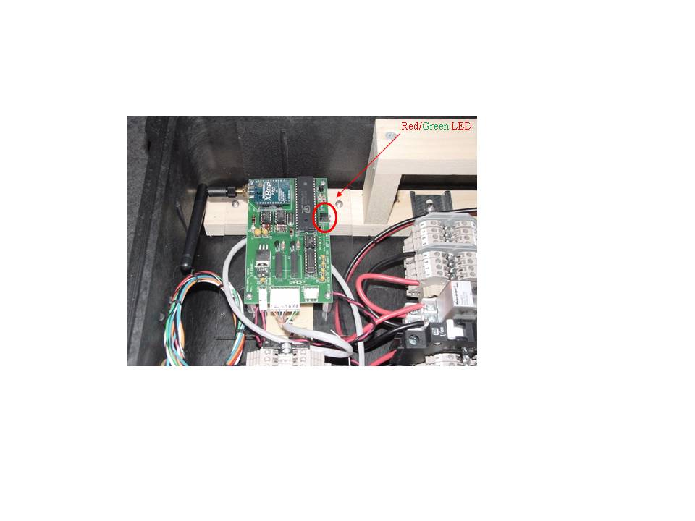

Figure 4: Rotate the monofilament attached to the downriggers to check if the encoders are working on the station. An LED light should display red when pulling one way, and display green the other way.

# Wireless Router Setup

The XBeePro routers are used to extend the range of the wireless downrigger control signals from the XBeePro Base Station to the individual downrigger control boxes. The specific locations of the routers are ship dependent; they need to be placed in unobscured locations so that the wireless signal can reach all downriggers. Make sure the routers are freshly charged and turned on. It takes about 1.5 hours to charge the routers. They can also be run off A/C via the Tenergy chargers. Battery life will be shortened in cold conditions. See Appendix IX.D for more information on the Tenergy batteries and chargers.

NOAA Ship Henry Bigelow router placement:

* One XBeePro router is located in the main deck corridor, adjacent to the AFT door that goes out to the back deck.
* Another router should be placed on the back deck. (Use a step ladder as a base for this router.)
* The third router should be placed up on the “Flying Bridge”, with a direct line of sight to the router on the back deck.

# EchoCal Software Setup:

## Install the software

The echocal GUI may be run from the desktop and does not need administrative permissions to install or execute. FTDI USB drivers are required to interface with the wireless base station. They should be obtained directly from FTDI: https://ftdichip.com/drivers/

## Initiate the software.

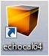Attach the XBeePro Base Station to the PC. Double click the “EchoCAL64” icon to launch the EchoCAL software GUI.

## Serial Port Configuration:

1. In the Serial Port Configuration tab (Figure 4), click “Refresh ports” button
2. Using the drop down list, select the correct COM port for the XBeePro Base Station. Note: You may need to open the Windows’ “Control Panel”, and find the appropriate COM port that has been assigned to the EchoCAL Base Station in “Device Manager.”
3. Once you’ve found the correct port, click the “Scan” button. After about 20 seconds, all devices connected should be displayed in the “EchoCal devices discovered” text box. (EK60C001, EK60C002, EK60C003). Note: If it does not display all devices, scan again. Bad connections may be due to routers not being placed correctly, or a battery in a router may be dead.

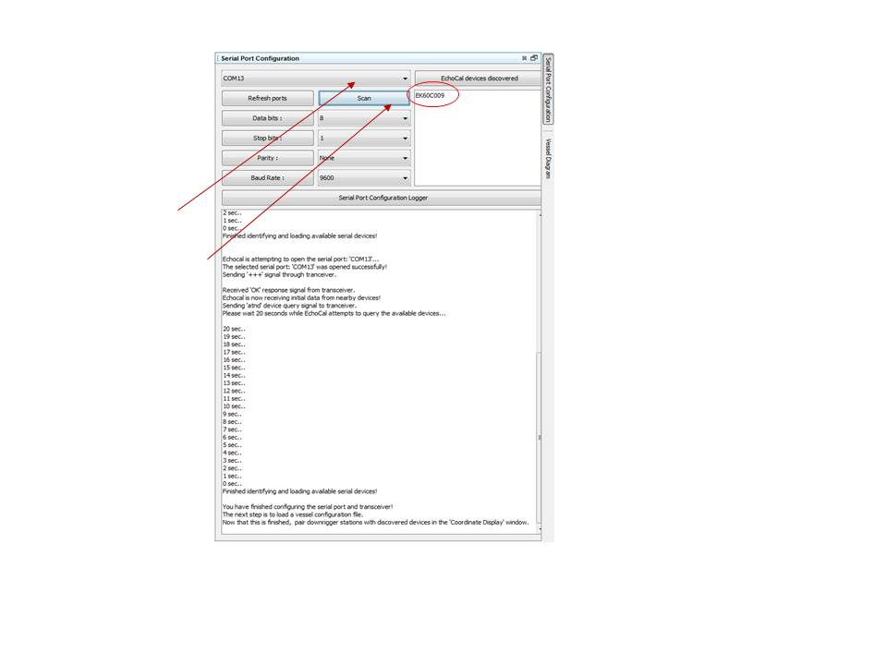

Figure 5: Serial Port Configuration interface.

## Configure EchoCal for the ship.

The EchoCAL software requires accurate measurements on how the individual downriggers are located on the vessel**.** The “Vessel Configuration Files” are XML based documents that record the distances between the downriggers, as well as the forward downrigger location relative to the echosounder transducer on the vessel**.** These measurements allow the software to calculate where the sphere is located in the water column**.** To load the Vessel Configuration File, perform the following steps:

### Load the Vessel Configuration File.

* Select the Coordinate Display Window tab, and click on the “Load config file” button (Figure 6).
* The Open dialog window will appear, allowing you to select the proper Vessel Configuration file. The file will be automatically uploaded. You can click the Vessel Configuration Tool tab to verify all readings loaded correctly.
* Configuration Files can be saved and loaded from previous sessions (.xml format). All inputs are in meters (m), and all heights are relative to ocean surface.

### Assign control box numbers to station locations.

Once the vessel configuration file is loaded, the individual station location controls will become active. Assign the control box serial number to each active station location using the pull down list in the Station Location Controls area.

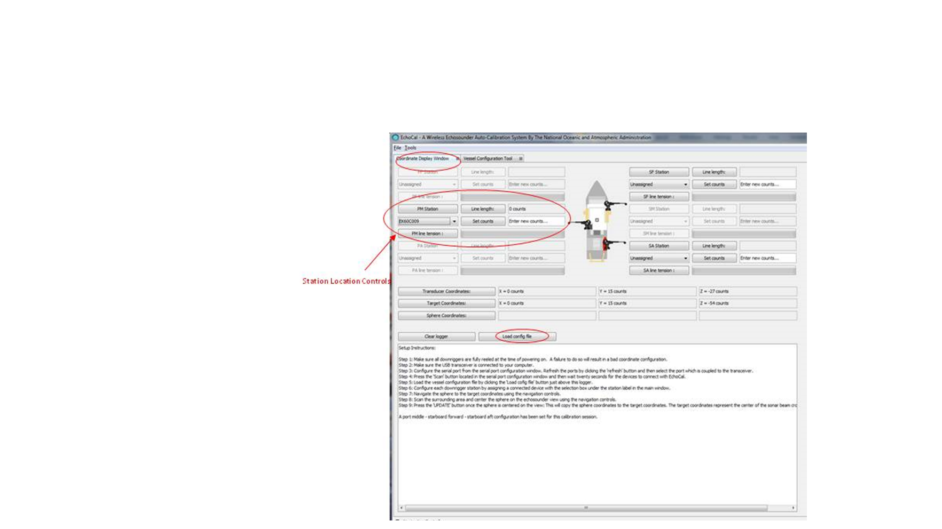

Figure 6: Vessel configuration interface

## Remote test of downrigger stations.

Once individual downrigger serial numbers are assigned to the active Station Location Controls, you can perform a brief test of the remote control of the downrigger stations**.** This testing will require two operators**.** One operator will be assigned to the downrigger station at the vessel rail**.** The second operator will control the EchoCAL software**.**

The following steps highlight how this testing is done using the *F/V Henry Bigelow* as an example setup**.** The *F/V Henry Bigelow* uses a three downrigger setup. (One downrigger on the port middle station, and two downriggers to starboard, one each at the starboard forward and aft stations.)

1. 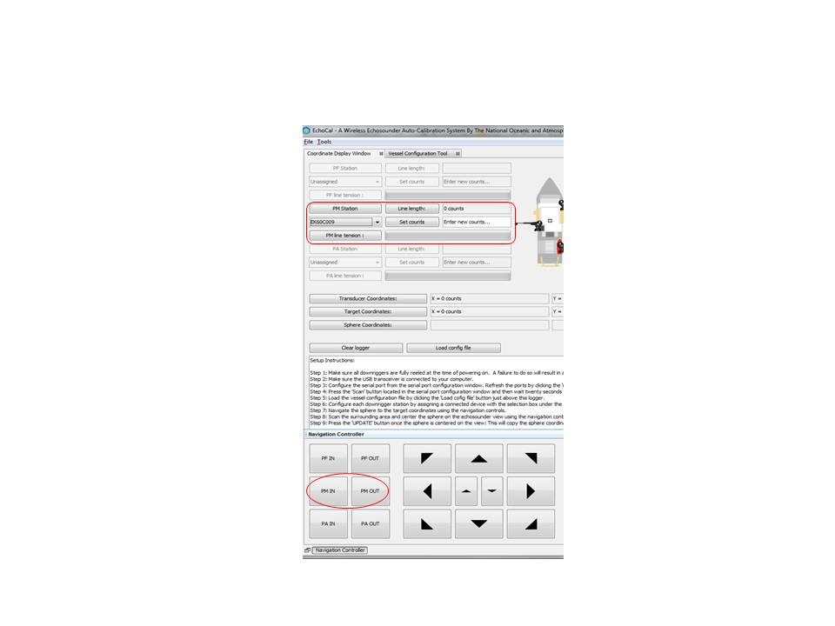Starting at the port middle position, the operator at that station will release the clutch on the downrigger so that the monofilament wheel will rotate freely, and then contact the operator at the controlling PC that the wheel is released.
2. The operator at the PC will select the Navigation Controller tab in the EchoCAL software GUI, and will then click on the PM OUT button twice and the PM IN button twice on the Navigation Controller**.** The operator at the downrigger station will confirm that the motor on the downrigger rotated.
3. Next, the operator at the downrigger station will tighten the clutch on the downrigger so that the motor on the downrigger will rotate the monofilament wheel**.** Once the clutch is tightened, the operator will inform the PC operator that the wheel is tight.
4. The operator at the PC will again remotely control the downrigger by clicking on the PM OUT and PM IN buttons**.** This operator should observe that the “counts” number to the right of the Line length button change depending on which way the motor was rotated**.** The operator at the downrigger station should inform the PC operator of the motion on the downrigger wheel**.** If the count does not change, verify the operation of the downrigger’s encoder as stated in Section III.A:4of this document.
5. **Pull the monofilament to the end of the downrigger.** This will be your”0” position, and the position prior to moving the monofilament together to connect at the sphere. Once the operation of the downrigger is confirmed and the monofilament is pulled to the end of the downrigger tip, verify that the “counts” on the downrigger are set to “0”**.** If the count is not at 0, use the Set counts button to zero the downrigger count.
6. **Repeat Steps 1 thru 5 for the two downrigger stations on the starboard side**

# Attach calibration sphere

Once the downriggers have been tested, the monofilament lines can be run to the location on the vessel where the calibration sphere and weight will be attached to the lines**.** For the *F/V Henry Bigelow*, do the following steps:

1. Pull the Port Side downrigger monofilament line under the hull of the vessel using standard calibration practices (Foote 1987) and secure temporarily to the ship’s rail.
2. On the starboard side, run both the Starboard Forward and Starboard Aft lines to the location where the calibration sphere will be attached and secure temporarily to the ship’s rail. You should now have updated counts (>0 counts for each downrigger).
3. Per standard calibration practices, tie all three downrigger monofilament lines, along with the 3-meter length of line for the sphere, securely together (now detached from the ship’s rail).
4. If not already connected, attach the sphere and weight to the 3-meter length of line.
5. Lower the weight and sphere into the water.
6. Using the downriggers, lower the sphere and weight into the water until the sphere is submerged about a meter below the ocean surface. **Make sure there is no excessive slack in any of the downrigger monofilament lines**.
7. Record the downrigger counts for the Port Middle, Starboard Forward, and Starboard Aft downriggers (Table 1, 2 or 3 depending on downrigger configuration).
   1. The “count” values in the EchoCAL GUI will only update when a command has been issued to each downrigger station**.** To update the “count” values, the operator at the PC should briefly click on the “IN” and “OUT” buttons for each downrigger station in the “Navigation Controller” window.
   2. This will give you a safe recovery point in a worst case scenario in which you lose the location of a sphere under the vessel and one or more of the downrigger control boxes lose power**.** A downrigger control box will reset to 0 counts if power is interrupted.

# Position sphere under transducer(s)

At this point, we are ready to automatically move the calibration sphere down into the echosounder beam at the depth specified in the Vessel Configuration File**.** When a configuration file is initially loaded into the EchoCAL GUI, the Transducer Coordinates and the Target Coordinates text fields are populated with values calculated from the initial measurements of the downrigger positions on the vessel (Figure 7).

The Transducer Coordinates will never change during the operation of the EchoCAL session**.** These coordinates represent the location of the transducer on the hull of the ship in downrigger “Count” units**.** The initial Target Coordinates are the “Count” values that the sphere should be initially guided to in order to bring the sphere into the echosounder beam below the vessel.

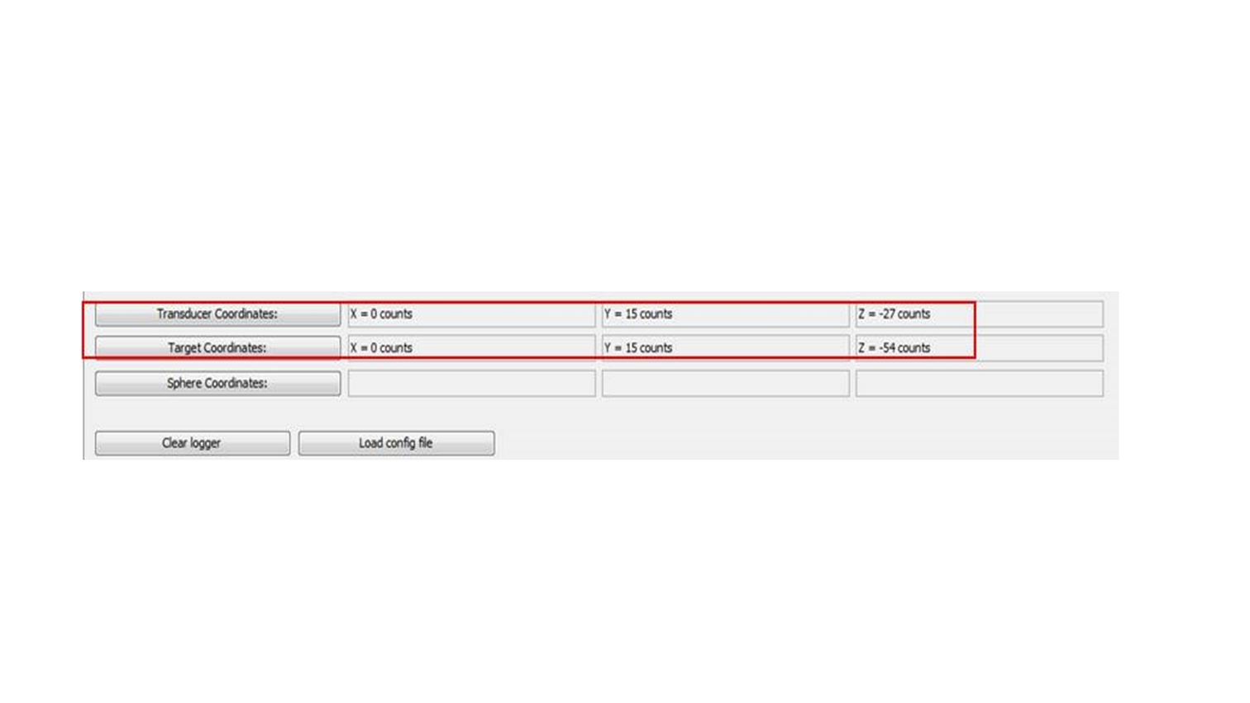

Figure 7: Coordinate counts table

## Navigate the sphere to initial Target Coordinates.

1. To navigate the sphere to the initial Target Coordinates, enter these X, Y, and Z values into the text fields below the “Navigate to position” button in the Navigation Controller tab.
2. Click on the “Navigate to position” button (Figure 8)**.** The EchoCAL program will now automatically move the sphere to the coordinates entered in these text fields**.** The software will output a message in the “Logger” text field on the Coordinate Display Window when the sphere has reached the target coordinates**.**
3. If something happens during this process or tension is too tight on any of the downriggers, you can press pause or stop. If you press pause, once the tension is loose enough you will hit play. If you pressed stop, then you must press “Navigate to position” again.
4. If the EchoCal crashes at any time repeat steps II, III, and VI. If the downriggers do not lose power during the time of the crash, then they will still have their counts recorded prior to the crash.
5. If the Navigation Controller tab does not appear on your display, see the Troubleshooting section (IX).

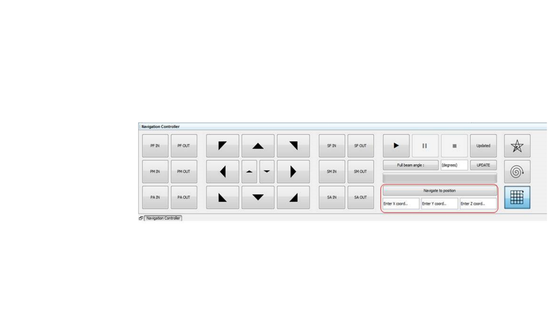

Figure 8: Sphere navigation interface.

## Find the sphere in the echosounder display.

Once the navigate function is complete, you should be able to see the sphere in the EK60 Echosounder display.

1. Using the virtual joystick buttons and the individual downrigger control buttons, manually move the sphere into the center of the frequency beam that you want to begin the calibration with**.**
2. Click the “UPDATE” button after you are in the optimal spot where the sphere should be for calibration**.** This button will update the Target Coordinates text fields with the new position of the sphere.
3. You should record the Target coordinates and the downrigger counts (Table 1.)**.**  If at any time the sphere gets out of the beam, you lose power, etc., you can find the sphere by putting in target coordinates, and the stations will navigate to this original position.

# Auto Calibration Session:

## Start recording with the echosounder software.

**IMPORTANT: Record the EK60 data with the ER60 software the entire time the sphere is in the water.**

This will allow the data to be replayed with appropriate settings (i.e. frequencies, ping rates) for the calibration file.

## Select an automated pattern available for calibration.

1. Select Grid, Star, or Spiral (Figure 9). For the *Henry Bigelow* calibration, use the Grid pattern for the automatic calibration session**.** The other patterns have not been thoroughly tested yet.
2. Enter the Beam Angle of the frequency that you will be calibrating**.** 
   * Note: Larger beam angles will result in the sphere spending a lot of time outside of the beams***.*** However, if you are trying to cover the area of many transducers bigger beam angles may be beneficial***.***

## Start the autocalibration

1. Click the “UPDATED” button, and then click on the VCR “Play” button (Figure 9). At this point, the automatic calibration session will begin**.**

* The progress bar below the “Full beam angle” button will show the progress of the calibration**.**
* Both the “Pause” and “Stop” buttons will be enabled to allow the operator to either pause or stop an automated calibration session if necessary**.**
* Patterns always start and return to the center, unless an error occurs.
* The star is usually the best pattern to use, i.e. quickest.

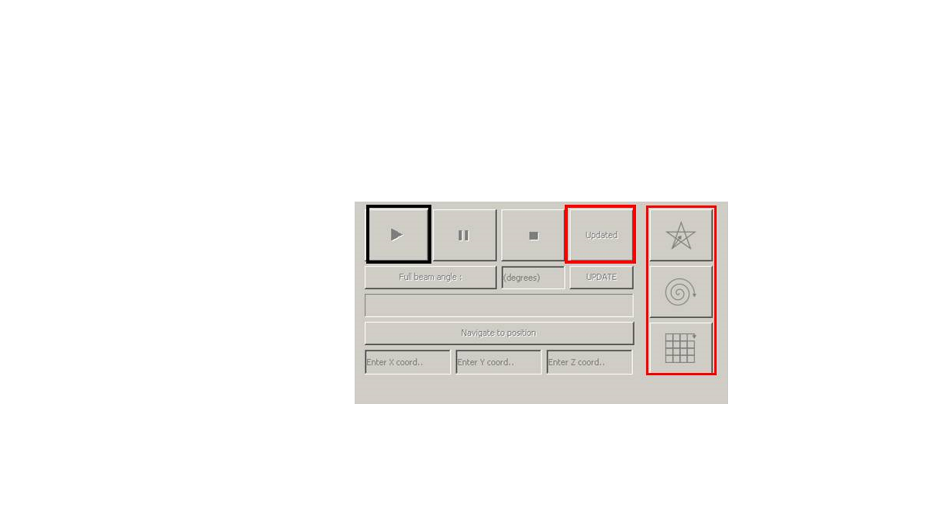

Figure 9: Automated pattern interface.

# Troubleshooting

## Improving the Graphical User Interface (GUI) for your situation

If the GUI does not show the correct panels or tabs, you can reset it to the default condition. This is especially useful when the Navigation Control tab/panel does not display correctly. This requires removing the .echocal directory from the AppData folder to force an update of GUI display settings.

1. Close EchoCal.
2. Use Window’s Explorer to navigate to C:/Users/*username*/AppData/Roaming, where *username* is the user you’ve logged in as. For example, on the 13” Dell laptop, most likely you’ve logged in as “Builtinadmin”.
3. Move the .echocal directory to the desktop. Don’t delete it right away in case something happens and you need it. What this does: hides the settings java? Is looking for and forces a new display setup.
4. Restart EchoCal.
5. After EchoCal reboots and you are happy, you can delete the .echocal directory on the desktop. A new .echocal directory will have been created and populated.

## “Floating” and “Docking” the panels/tabs

The panels/tables can be “floated” or “docked” relative to each other. Floating means the panel is independent of the other panels. The advantage to this is you can move that panel around the display. The disadvantage is that it will be covered by the other panels when those are selected. Docking means the panel is set in a location relative to the other panels and will be displayed when the other panels are displayed.

1. Float the Navigation Control Panel
   1. Right click on the Navigation Control tab
   2. Select “float group”
   3. You should see the Navigation Control panel open in its own window.
   4. You can use the “Tools” menu to display the different panels/windows.
2. Dock the Navigation Control Panel
   1. Right click on the Navigation Control tab
   2. Select “dock group”
   3. You should see the Navigation Control panel open at the bottom of the GUI and it is locked in place
   4. You can resize the panels to fit the display

## Change the default appearance

* + 1. Select Tools -> Options
    2. Select the ”Appearance” icon in the newly-displayed window.
    3. Select the “Look and Feel” tab.
    4. Select the look and feel option from the “look and feel” drop-down menu.
       1. The default is “Windows”
       2. I’ve been using “Metal” and it seems to work well.
    5. You must restart EchoCal for the selection to take effect.

## Latency or loss in communications

This problem manifests itself with the error “Downrigger $EK60XXX has lost communication with EchoCal”. This will happen if the base station’s AP mode is not “transparent mode [0]”. Information about these modes can be found on page 47, “Serial Modes” of the XBee®-PRO 900HP/XSC RF Modules S3 and S3B User Guide. The XTCU software is required to change the mode in the base station.

# Appendices

## EchoCal Components Inventory/Checklist

|  |  |  |
| --- | --- | --- |
| **EchoCal Components Inventory** | | |
| **Item** | **Quantity & comments** | **Packed?** |
| Wireless controlled downrigger | 4 downriggers  The HB Bigelow only needs 3, but bring four just in case one is bad. Confirm that the monofilament is in good quality and sufficient length |  |
| Wireless control Pelican case “control box” | 4 control boxes  The HB Bigelow only needs 3; bring four just in case one is bad |  |
| “Cables” Pelican case | 1 pelican case  Confirm that there are  4 sets of cables. A set is: power cable, Ethernet cable, and two downrigger cables  4 Downrigger control boxes (small boxes that attach to the downrigger) |  |
| “Routers” Pelican case | 1 pelican case  Confirm that there are:  1 wireless base station  4 wireless routers  4 chargers with charging cables |  |
| Wooden downrigger mounts | 4 mounts  The HB Bigelow only needs 3; bring four just in case one is bad |  |
| Electrical extension cords | 3  Need long lengths |  |
| Laptop | 1  Confirm the EchoCal software is loaded and this user manual is on the desktop |  |
| Calibration spheres | The yellow Pelican case with spheres should remain on the F/V Henry Bigelow. For other vessels, there is a grey Pelican case in the gear shed. |  |
| “Bow” line | Line for straddling the ship and tossed over the bow used to transfer the mid monofilament to the opposite side. Bring two lines to make sure it is long enough. |  |
| Weight | Weight for the bow line. Approximately 10 lbs |  |
| Weights | Weights to suspend under the sphere, such as one or two 5-10 lb dive weights. Bring plenty to add in case of current. |  |
| Monofilament | We typically use 50-lb test for the downriggers and 40-lb test for the sphere. |  |
| Radios | 5  Motorola radios with channels 1-3 programmed for the F/V Henry Bigelow |  |
| USB memory stick | It is a good idea to have EchoCal software, documentation backed up to a memory stick |  |

## Appendix: Forms to record target position

## Table 1. Starboard forward, port mid, starboard aft downrigger configuration. This is the downrigger configuration for the F/V Henry Bigelow.

|  |  |  |  |  |  |  |
| --- | --- | --- | --- | --- | --- | --- |
| Downrigger Counts: | | | Target Coordinates: | | | Position |
| STBD FWD  (Counts) | PORT MID  (Counts) | STBD AFT  (Counts) | X | Y | Z |
|  |  |  |  |  |  |  |
|  |  |  |  |  |  |  |
|  |  |  |  |  |  |  |
|  |  |  |  |  |  |  |
|  |  |  |  |  |  |  |
|  |  |  |  |  |  |  |
|  |  |  |  |  |  |  |
|  |  |  |  |  |  |  |
|  |  |  |  |  |  |  |
|  |  |  |  |  |  |  |
|  |  |  |  |  |  |  |
|  |  |  |  |  |  |  |
|  |  |  |  |  |  |  |
|  |  |  |  |  |  |  |
|  |  |  |  |  |  |  |
|  |  |  |  |  |  |  |
|  |  |  |  |  |  |  |
|  |  |  |  |  |  |  |
|  |  |  |  |  |  |  |
|  |  |  |  |  |  |  |

## Table 2. Port forward, starboard middle, port aft downrigger configuration.

|  |  |  |  |  |  |  |
| --- | --- | --- | --- | --- | --- | --- |
| Downrigger Counts: | | | Target Coordinates: | | | Position |
| PORT FWD  (Counts) | STBD MID  (Counts) | PORT AFT  (Counts) | X | Y | Z |
|  |  |  |  |  |  |  |
|  |  |  |  |  |  |  |
|  |  |  |  |  |  |  |
|  |  |  |  |  |  |  |
|  |  |  |  |  |  |  |
|  |  |  |  |  |  |  |
|  |  |  |  |  |  |  |
|  |  |  |  |  |  |  |
|  |  |  |  |  |  |  |
|  |  |  |  |  |  |  |
|  |  |  |  |  |  |  |
|  |  |  |  |  |  |  |
|  |  |  |  |  |  |  |
|  |  |  |  |  |  |  |
|  |  |  |  |  |  |  |
|  |  |  |  |  |  |  |
|  |  |  |  |  |  |  |
|  |  |  |  |  |  |  |
|  |  |  |  |  |  |  |
|  |  |  |  |  |  |  |

## Table 3. Four-downrigger configuration. Port forward, port aft, starboard forward, starboard aft downrigger configuration.

|  |  |  |  |  |  |  |  |
| --- | --- | --- | --- | --- | --- | --- | --- |
| Downrigger Counts: | | | | Target Coordinates: | | | Position |
| PORT FWD  (Counts) | PORT AFT  (Counts) | STBD FWD  (Counts) | STBD AFT  (Counts) | X | Y | Z |
|  |  |  |  |  |  |  |  |
|  |  |  |  |  |  |  |  |
|  |  |  |  |  |  |  |  |
|  |  |  |  |  |  |  |  |
|  |  |  |  |  |  |  |  |
|  |  |  |  |  |  |  |  |
|  |  |  |  |  |  |  |  |
|  |  |  |  |  |  |  |  |
|  |  |  |  |  |  |  |  |
|  |  |  |  |  |  |  |  |
|  |  |  |  |  |  |  |  |
|  |  |  |  |  |  |  |  |
|  |  |  |  |  |  |  |  |
|  |  |  |  |  |  |  |  |
|  |  |  |  |  |  |  |  |
|  |  |  |  |  |  |  |  |
|  |  |  |  |  |  |  |  |
|  |  |  |  |  |  |  |  |
|  |  |  |  |  |  |  |  |
|  |  |  |  |  |  |  |  |

## Appendix: EchoCal GUI description

Coordinate display window

The Coordinate Display window displays to the user all relevant information regarding the state of the calibration sphere’s position and the geometry associated with the vessel configuration. The coordinate display window also provides six ‘Downrigger Station Controls’ which provides all the tools necessary for configuring the downrigger stations (Figure 10). There is a real-time logger available which displays various forms of information associated with calibration session.

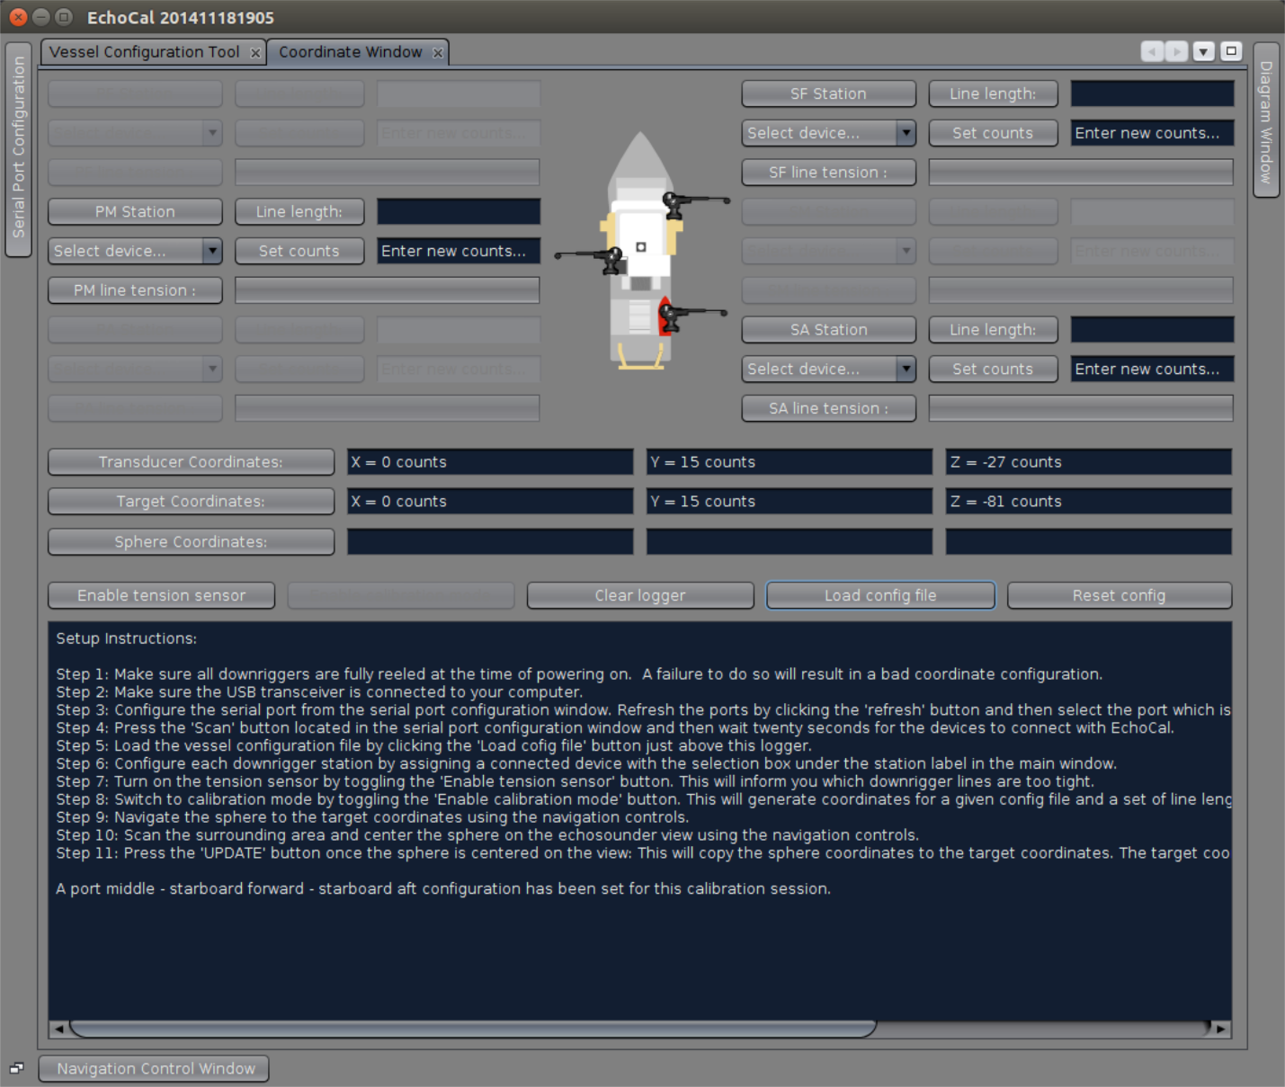

Figure 10: Coordinate display window.

Downrigger station controls

The downrigger station controls represent six sets of identical controls for each possible downrigger station. A calibration session will usually utilize three downrigger stations. The downrigger station controls are located above the coordinate gauges in the coordinate display window. Each set of controls contain a downrigger count gauge, a count reset input field, a count reset button, a tension gauge and a downrigger station box selection menu.

Downrigger count reset controller

The count reset and input field is located in each set of downrigger station controls. It may be used to re-program the counts associated with a downrigger station. These controls are used for testing purposes and should not be used during calibration sessions unless power was somehow lost to the downrigger boxes. Then the count coordinates would reset to zero once power is turned back on. These controls allow the user to reprogram the counts perceived by the hardware so that the calibration session may continue without reeling the line in. It is a good practice to write down the downrigger coordinates on a pad of paper in case EchoCal shuts down (see example forms in IX.B: Appendix: Forms to record target position).

Target coordinates

The ‘Target Coordinates’ display gauges the ‘echogram target position’ in Euclidian coordinates which reflects the echo-gram's center point. These coordinates along with all other are represented in downrigger ‘count’ units which are approximately equal to 0.185 meters. This position acts as a central reference point which the auto-calibration functions will requires to navigate around. This position is automatically generated from a loaded vessel configuration file but it is essential that the user updates the target coordinates with the ‘Update’ button before any calibration session is initiated otherwise it will result in a poor calibration session. The initial set of target coordinates generated from the loaded vessel configuration file represents a calculated set of target echo-gram coordinates which are given to the user as a region to begin scanning until the calibration sphere has been spotted on the echosounder. It should be noted that the accuracy of the vessel configuration measurements directly reflect the accuracy of the initial target coordinates so vessel configuration measurements must be accurate. The **update** button will copy the current position of the calibration sphere to the target coordinates so only press this button when the calibration sphere is centered on the echo-gram view.

Calibration sphere coordinates

The *sphere coordinate display* gauges the real-time calibration sphere position in Euclidean coordinates. These coordinates along with all other are represented in downrigger ‘count’ units which are approximately equal to 0.185 meters.

Transducer coordinates

The *transducer coordinates* display gauges the transducer position in Euclidean coordinates. These coordinates along with all other are represented in downrigger *count* units which are approximately equal to 0.185 meters. These coordinates are simply available for reference but they are not directly essential to the calibration.

Vessel configuration gauge

The vessel configuration gauge is a vessel top view graphic located between the port and starboard downrigger station controls which indicates to the user the vessel configuration associated with the current calibration.

EchoCal logger

The EchoCal logger provides real-time information associated with all forms of navigation and set-up procedures. It is located at the bottom of the coordinate display window.

Vessel configuration

A vessel configuration file is a file which contains information regarding the specific geometric configuration associated with the calibration set-up. It provides information regarding the relative positions of each downrigger station, the ships transducer and an approximation of the echo-gram target coordinates (Figure 11). Try to obtain a copy of the vessel schematics if possible.

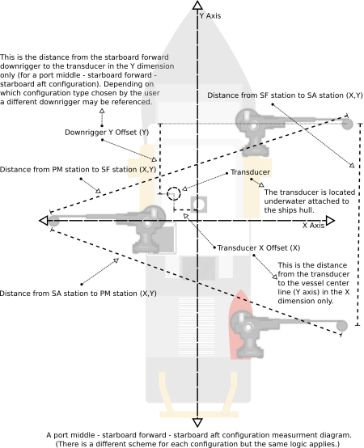

Figure 11: Top view of vessel measurement layout.

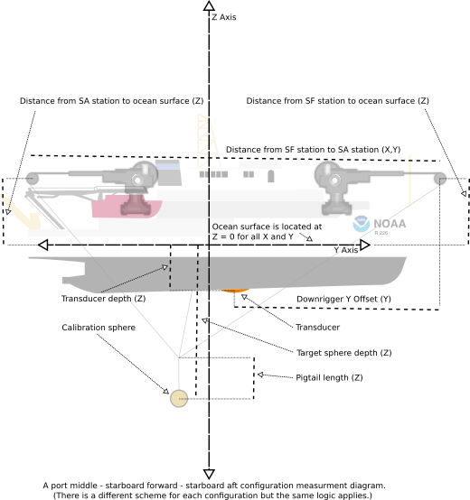

Figure 12: Side view of vessel measurement layout.

Creating a vessel configuration file

To create a vessel configuration file, select the vessel Configuration tool from the tools menu (Figure 11). Depending on the configuration type chosen from the drop-down menu on the left column will certain numerical inputs be provided. The leftmost column asks for information regarding the height of the downrigger's pole end to the ocean surface.

The distance ‘from’ and ‘to’ entry fields are variable and change with the vessel configuration type selection. For example, in Figure 12, there is a measurement from the Starboard Forward (SF) downrigger to the Starboard Aft (SF) downrigger. In the rightmost column the user enters the distance in meters in a straight line between the ‘from’ and ‘to’ downrigger stations. The vessel width, transducer depth and target depth input fields refer to the distance of the vessels width, the depth of the transducer from the ocean surface and the estimated depth of the echo-gram target coordinates in meters respectively. The Transducer X offset input field refers to the distance in meters of the transducer from the Y axis which runs down the center of the ship. The ‘downrigger Y offset’ input field label varies with the vessel configuration type selection and it asks for the distance along the Y axis from some downrigger to the transducer. One finished, press the ‘Save As...’ button to prompt a path-to-save box.

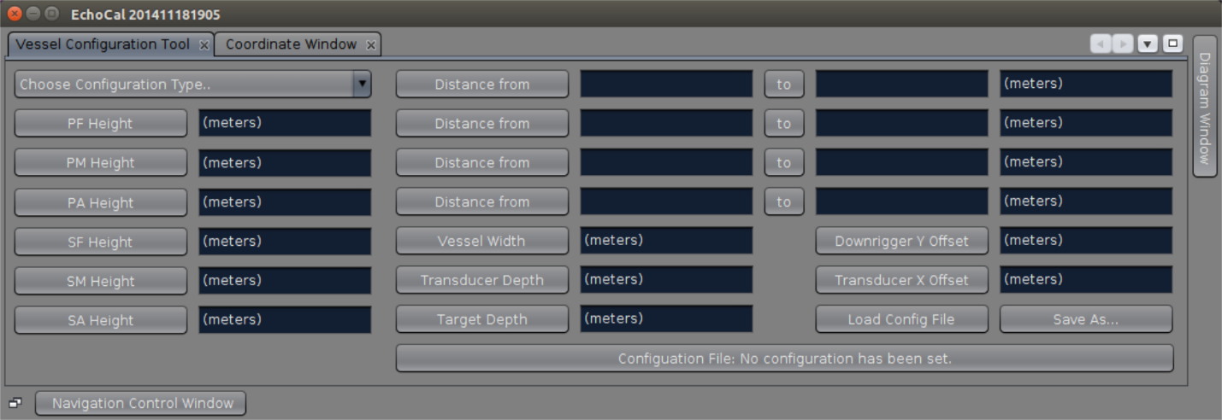

Figure 13: Vessel configuration tool.

Loading a vessel configuration file

The user can load a vessel configuration file with the ‘Load Config’ button located in the coordinate display window (Figure 10) and the vessel configuration tool (Figure 13). The software will prompt a path-to-load-from box and generate a set of coordinates for the transducer and target echo-gram coordinates.

Serial port configuration

The serial port configuration window was designed to help the user configure the serial port connected to the transceiver which communicates with EchoCal downriggers and routers. At startup the serial port configuration window may be accessed by the tools menu (Figure 14).

To connect to the downriggers, make sure the power is turned on for each downrigger and router, and the transceiver (base station) is plugged into the computer that is running the EchoCal software. Press the ‘Refresh ports’ button to query the available serial ports on your computer and select the serial port from the drop-down menu located at the top. Configure the serial port by selecting the characteristic choices available below the ‘Scan’ button. After configuring the serial port, press the ‘Scan’ button to connect to the EchoCal downriggers. The ‘Serial port configuration logger’ will display the metadata associated with the connection and after twenty seconds the connection process will be complete. After completing this task you may close the serial port configuration window. To change the properties of the serial port just open the serial port configuration window and repeat the process described in this section.

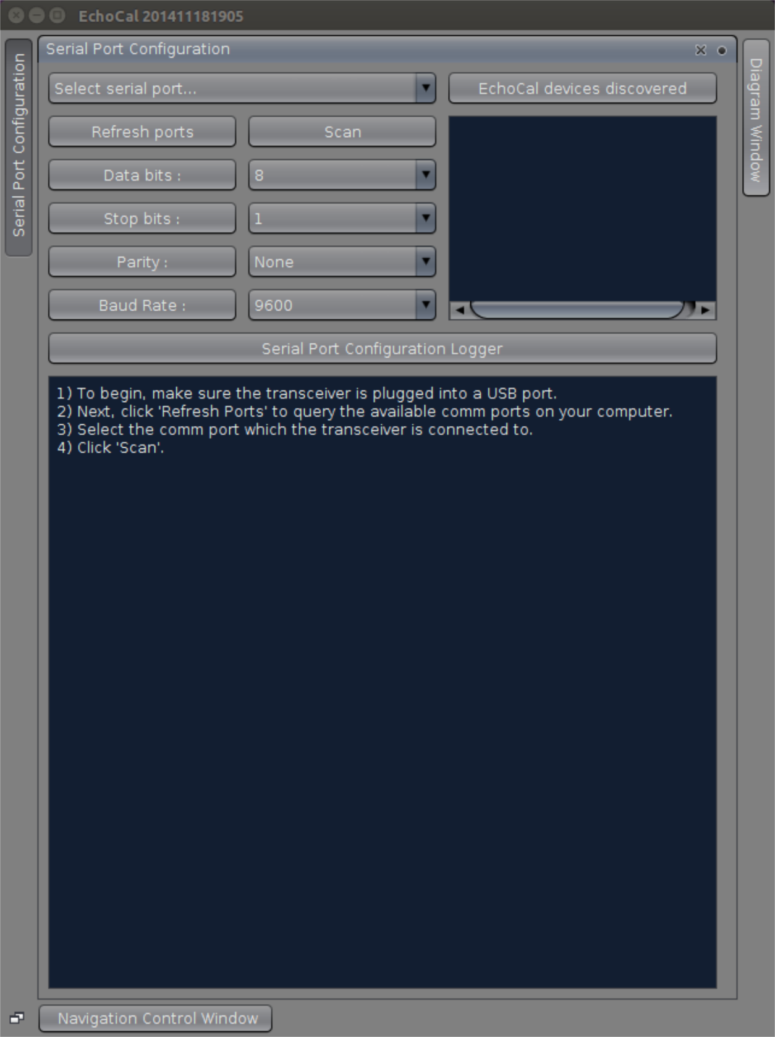

Figure 14: Serial port configuration window.

Navigation controller window

There are four types of navigation controllers worth classifying. The rudimentary reeling controller, the virtual joystick controller, the auto-navigation controller and the auto-calibration controller. All of these controllers are available in the ‘Navigation Control’ window (Figure 15). This along with the coordinate display window will serve as your main interface during calibration after the devices have been configured properly.

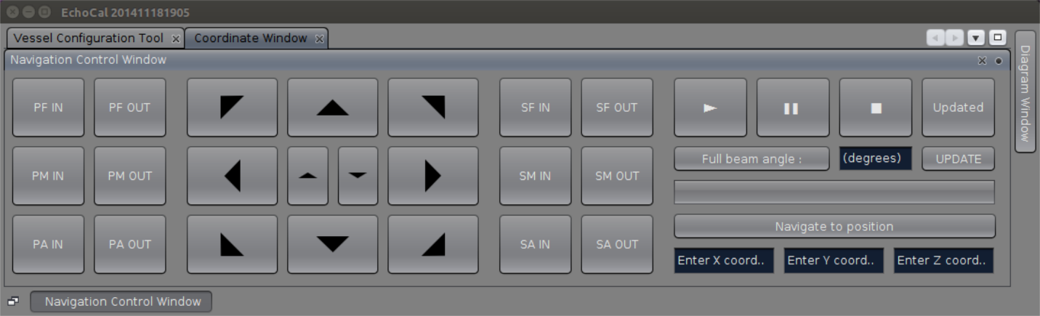

Figure 15: Navigation control window.

Rudimentary reeling controls

The ‘rudimentary reeling controller’ demonstrates the most basic set of navigation functionality EchoCal offers. Every single navigation function is built from more complex manipulation of these particular functions. Essentially a ‘REEL IN’ or ‘REEL OUT’ command will be available for each downrigger station which has been configured properly and they are located on the left and right of the virtual joystick. There is a small built in delay which renders each button unusable as the downriggers are in a current state of motion. Each execution of the reel commands will reel on average a single count unit. The ‘count’ unit was invented for this reason; so that reel commands and count units are correlated.

Virtual Joystick Controls

The ‘virtual joystick’ controls are located in between the two sets of ‘rudimentary reeling’ controls. The joystick functionality can be understood in terms of the ‘auto-navigation’ function since it directly utilizes it. Each directional button executes an ‘auto-navigation’ command and uses the calibration sphere position to calculate the intended coordinates of navigation. Each directional button displaces the sphere to a nearby point from the calibration sphere position in the direction reflected by the directional button. The directional buttons located in the center of the joystick reflect the rise and sink commands which displace the sphere in the z-axis only.

Auto-navigation controls

The ‘auto-navigation’ controller is located at the bottom right hand side of the navigation controls and it consists of a coordinate input and a ‘Navigate’ button. ’The ‘Navigate’ button should be used to displace the calibration sphere to a single position which is specified by the ‘Navigation Coordinate Input’ text fields. Keep in mind that these coordinates are measured in ‘count’ units which were designed to simplify general navigation. To input coordinates just enter a desired count number in each coordinate field. Use the coordinate display window to get a general Idea where the target position is in reference to the calibration sphere.

Auto-navigation algorithm

As discussed in a previous section, the navigation calculations are processed in the downrigger coordinate system. This section describes these functions in more depth. The downrigger coordinates may be visualized as an array of six coordinates: port forward counts, port middle counts, port aft counts, starboard forward counts, starboard middle counts, starboard aft counts. There is a single coordinate for each downrigger, and almost always only three downriggers are present. An example set of downrigger coordinates may look like this: 120, NULL, 102, NULL, 81, NULL. After a user executes an auto-navigation command correctly, the auto-navigation function will convert the user-in-putted Euclidean coordinates of intended navigation to a set of downrigger coordinates. Next the EchoCal system will check for the sign and magnitude of the difference between the actual downrigger coordinates and the downrigger coordinates of intended navigation and execute a single real function one station at a time until the two sets of coordinates are identical. This allows for a very smooth transition from one position to another underwater.

Auto-calibration controls

The ‘auto-calibration’ function is a handy function which has contributed most of the time saved by EchoCal. This function builds an array of coordinates which fall inside the echograms view and essentially navigates the calibration sphere to them with the objective of hitting as many points as possible in the shortest time. During development the goal of this function was to create a set of points which reduced the redundancy of travel distance by the calibration sphere so that more time was saved.

There are two modes of path generation for the auto-calibration function: the star-type auto-calibration and the spiral-type auto-calibration. Depending on various factors such as sea current speed and direction or ship size, one mode may work better than another. The ‘star’ and ‘spiral’ make reference to the paths which the calibration sphere draws out when seen from the echogram. The star type auto-calibration is designed to span the diameter of the echogram while slowly shifting the angular coordinate with respect to the X axis upon every full diameter span until the angular value reaches 360 degrees. This will draw out a star pattern but only on calmer days will its shape become more distinct. Interestingly enough, this function also has proven to be extremely valuable when the calibration sphere is lost from the echograms view. Unlike the spiral-type auto-calibration function, this one can scan large distances relatively quickly. The spiral type function is more time efficient because it doesn't hit a single point redundantly however it should not be used when scanning the ocean since it would cover very little area compared to the star-type auto-calibration function.

These functions can be utilized with the ‘auto-calibration’ controller which is located directly above the ‘auto-navigation’ controller on the right hand side of the ‘navigation controls’ window. Before you can perform an auto-calibration session you must already know the full beam angle in degrees of the echosounder. The cross-sectional area of the echogram is dependent on the echosounder beam angle. The ‘full-beam-angle’ input field will process this number upon execution of an auto-calibration function. The second direct dependency of the auto-calibration functions is the ‘UPDATED?’ toggle-button which essentially asks the user if he/she has updated the target coordinates so that they are accurate. This is essential since the auto-calibration functions utilize the target position as a reference point when generating a coordinate path array. Whether or not the target coordinates are accurate (to which EchoCal has no ability to capture the information on its own), an auto-calibration function cannot begin without a pressed ‘UPDATED’ button. The calibration progress bar located directly under the ‘full-beam-angle’ input field will indicate the user the auto-calibration progress. The calibration sessions may be executed with the ‘Play’ button, paused with the ‘Pause’ button and stopped with the ‘Stop’ button as one would find on an audio-playback device.

Vessel diagram window

The coordinate display and auto-navigation controller of the EchoCal user interface use a Euclidean coordinate system to describe the relevant positions of key objects and locations. These gauges are useful but the actual navigation related calculations are processed in a ‘downrigger’ coordinate system.

Downrigger coordinate system

The downrigger coordinate system can be described as follows: The length of each mono filament line from one pole-end of a downrigger to the point where the all lines meet describes a single downrigger coordinate. The calibration sphere is not usually located at the point where the lines meet but are correlated and are only offset from one another in the z-dimension as a result of its pigtail configuration of lines. The downrigger coordinate system makes use of the ‘downrigger count’ units which were designed to reflect the average adjustment of length per rudimentary reel function execution. EchoCal and its foundational functionality is built from its implementation of reversible-transformation functions which interface Euclidean and downrigger coordinates. The equations which transform the Euclidean coordinates to downrigger coordinates are many times more efficient than the equations for the reverse transform since it only makes use of the Pythagorean theorem. The conversion of downrigger coordinates back to Euclidean coordinates uses a four-tier self-correcting approximation scheme which essentially works by feeding sample Euclidean positions into the previous transform for the sake of locating the point which most closely produces the current downrigger coordinates after transformation; This process is repeated four times per coordinate update and with each iteration a more accurate Euclidean point is calculated by checking nearby points. The calculations are processed in real time whenever ‘Calibration Mode’ is turned on. Since these calculations are computationally expensive, calibration mode should only be turned on when the user is navigating the calibrations sphere. Larger vessels will require more memory to calculate Euclidean positions since a larger volume of underwater space will be processed. The ‘Calibration Mode’ toggle button is located in the coordinate display window just above the EchoCal logger. Only when calibration mode is turned on will the calibration sphere coordinates be available in the coordinate display window. Keep in mind that there is a third coordinate system in effect: The Vessel Configuration coordinate system. The vessel configuration coordinate system is Euclidean and can be thought of as a reference map or a set of constants associated with the geometrical configuration of downriggers as they were set up on the vessel. These constants are generated from a ‘Vessel Configuration’ XML file and is needed for two reasons: to generate an initial estimate for the ‘Target Echogram’ position and to calculate the theoretical distance between the downriggers and the calibration sphere; theoretical downrigger coordinates. The theoretical downrigger coordinates are measured against the actual downrigger coordinates during coordinate transformation as discussed before and uses the difference between the two sets of downrigger coordinates as a way to gauge accuracy of the coordinates generated in the coordinate display window.

Downrigger to Euclidean coordinate transformation

Figure 16 will help visualize how the downrigger-to-Euclidean coordinate transformation works. An approximation method acquires the coordinates, thus no exact solution is available. Each grid size makes reference to a different approximation scale for a set of Euclidean coordinates which indicate the position of the calibration sphere. Each circle represents the closest point to the actual position of the sphere. It is easy to tell which point is closer to the actual position but there is no straightforward way to acquire the position. The downrigger coordinates are known, and there is no straightforward way to acquire the Euclidean coordinates.

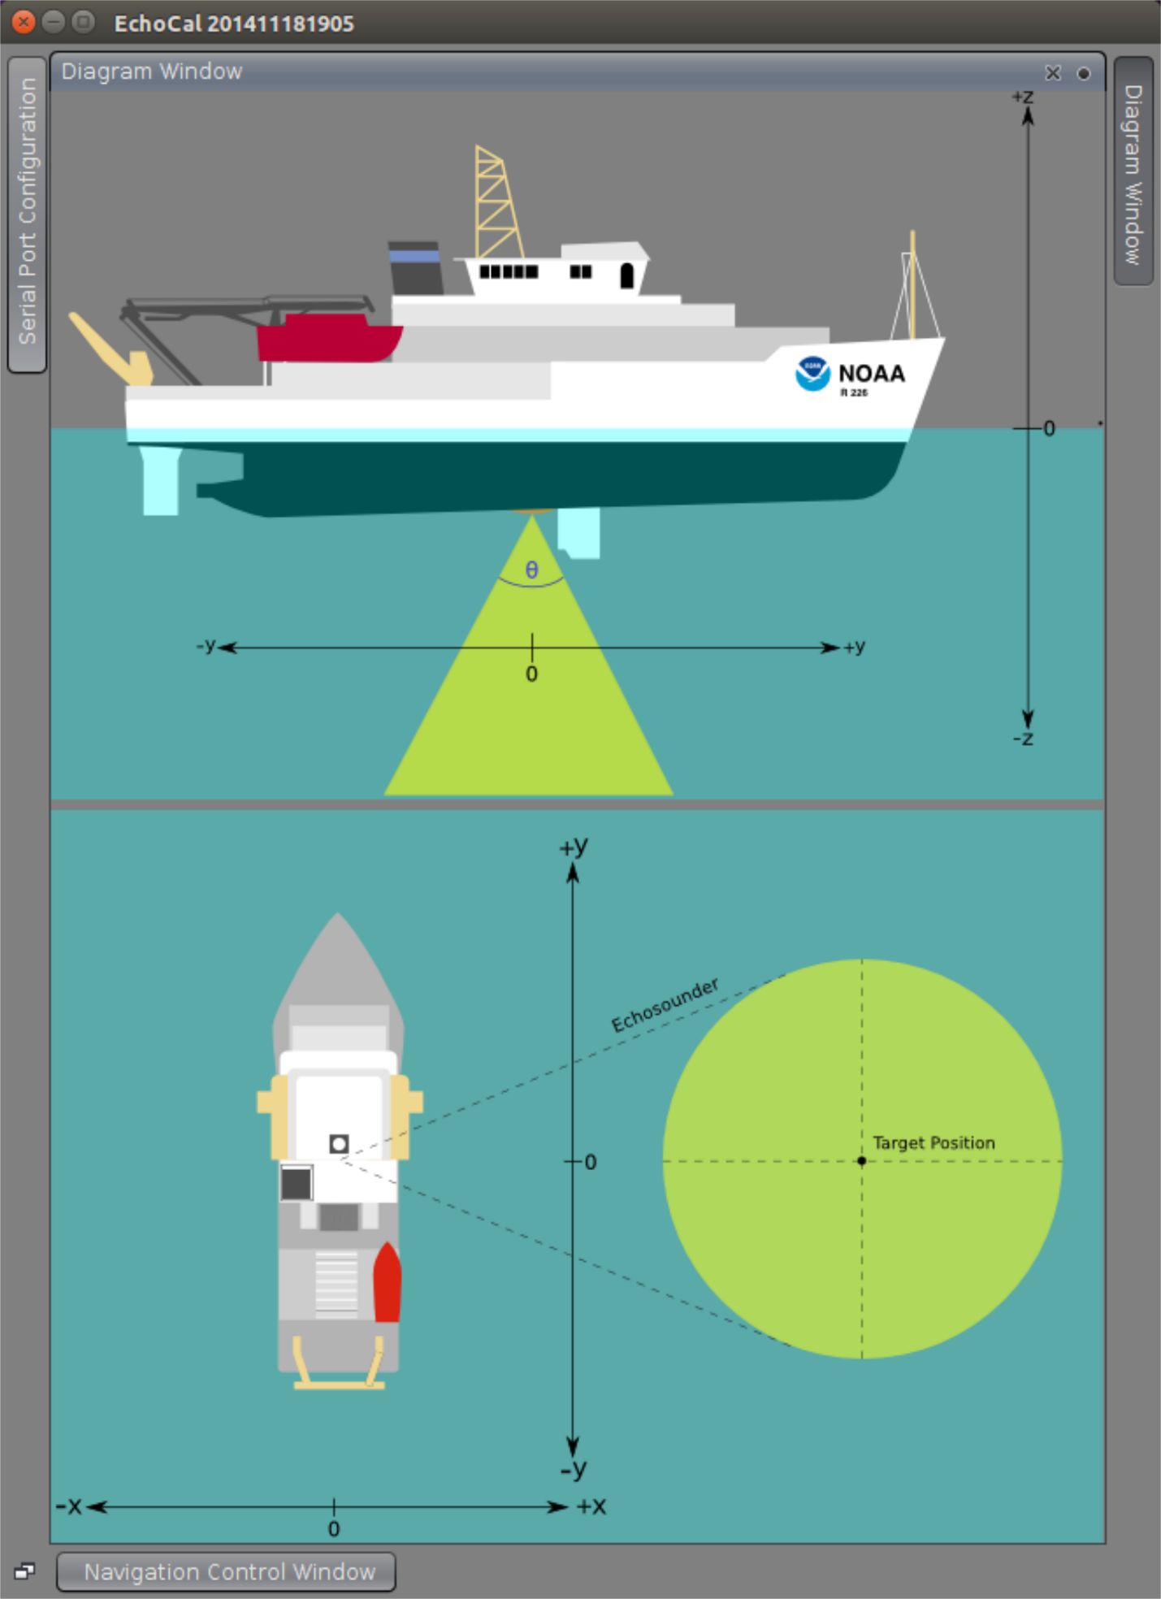

Figure 16: Vessel diagram window.

## Appendix: EchoCal GUI installation

**GUI Software Installation Manual**

Introduction

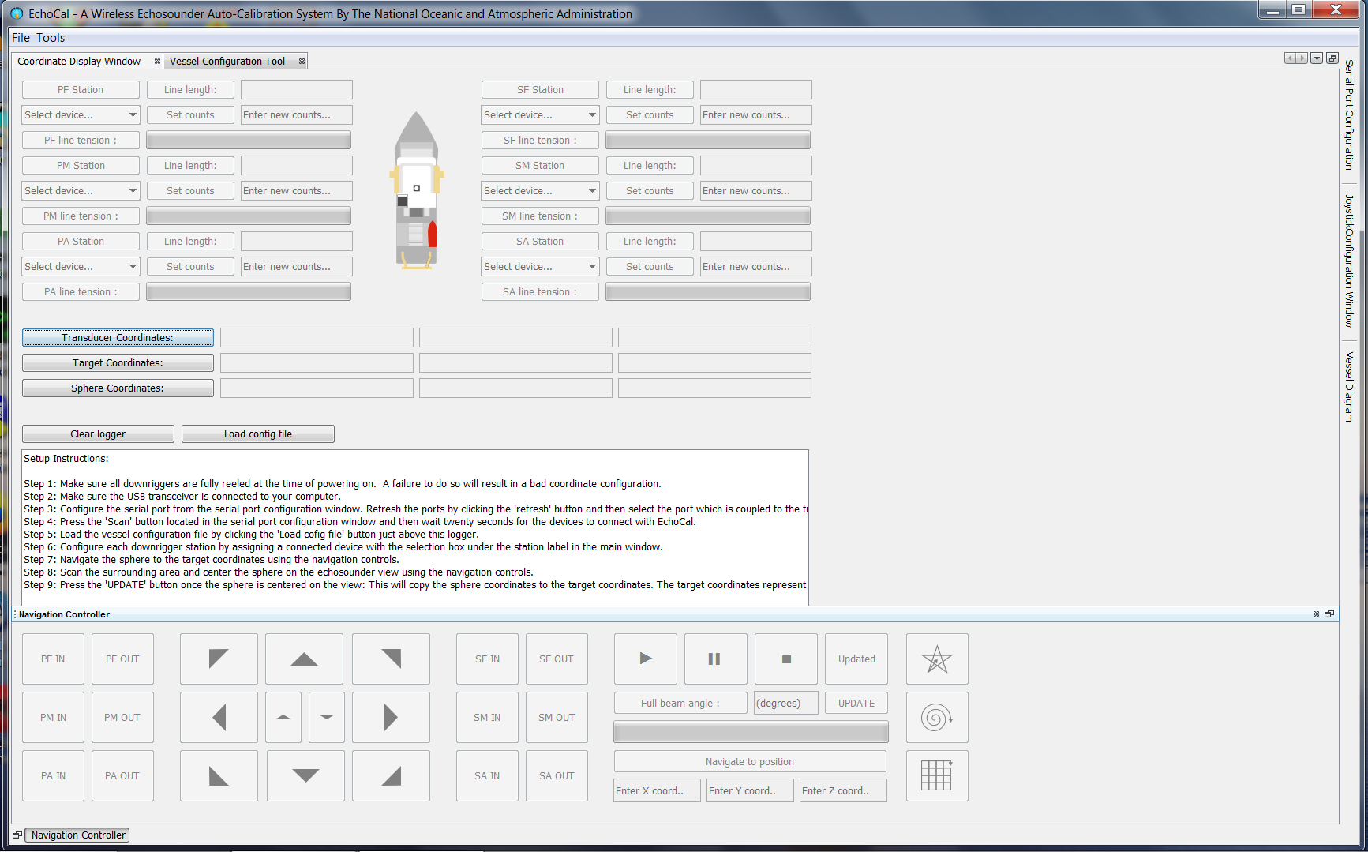

Figure 17: EchoCAL Graphical User Interface (GUI)

The *EchoCAL* Graphical User Interface (GUI) provides the software interface which controls the system of powered downriggers for echosounder calibrations. This GUI can be installed on any 64-bit Linux or Windows based PCs in three different ways.

* The first method is by downloading the executable binary files that are installed in the “**bin**” folder on the *EchoCAL* GitHub site.  
   (<https://github.com/MMartini1/PEMAD-ESB-EchoCAL>)  
  Seesection X.D:2 **o**n how to install *EchoCAL* from binaries on page 36 of this document.
* The second method is to download all of the *EchoCAL* GUI JAVA project files and open them in the [Netbeans Integrated Development Environment (IDE)](https://netbeans.org/). These project files are located in the “**EchoCAL_GUI_Source/EchoCal_Ver1.2**” folder on the *EchoCAL* GitHub site. See **Section 3** of this manual on how to load the project files into the Netbeans IDE and run the *EchoCAL* application.
* The user can also create the *EchoCAL* executable binaries using the *EchoCAL* GUI project files. This will come in handy if the user needs to fix problems or add features to the code at a later date. See **Section 4** of this manual for instructions on creating a packaged executable distribution of the *EchoCAL* software.

Installing *EchoCAL* Graphical User Interface (GUI) from binaries (recommended):

Installing *EchoCAL* using the binaries developed for this system is the easiest and quickest method of testing the hardware and conducting echosounder calibrations. The *EchoCAL* application contains a copy of the JAVA Runtime Environment (JRE) embedded with the application. The user can run *EchoCAL* on any PC, even if a version of JAVA is not installed on that machine. To install *EchoCAL*, perform the following steps:

1. Download the *EchoCAL* executable files from the *EchoCAL* GitHub web site appropriate to the operating system to be used. For a Windows 64-bit Operating System, download the *EchoCAL* files from the “**bin/Win64**” folder on the GitHub site.
   1. Navigate to the *EchoCAL* GitHub site (<https://github.com/jmgodlewski/EchoCAL>) using any web browser, and select the “bin/Win64” folder. (Figure 11)

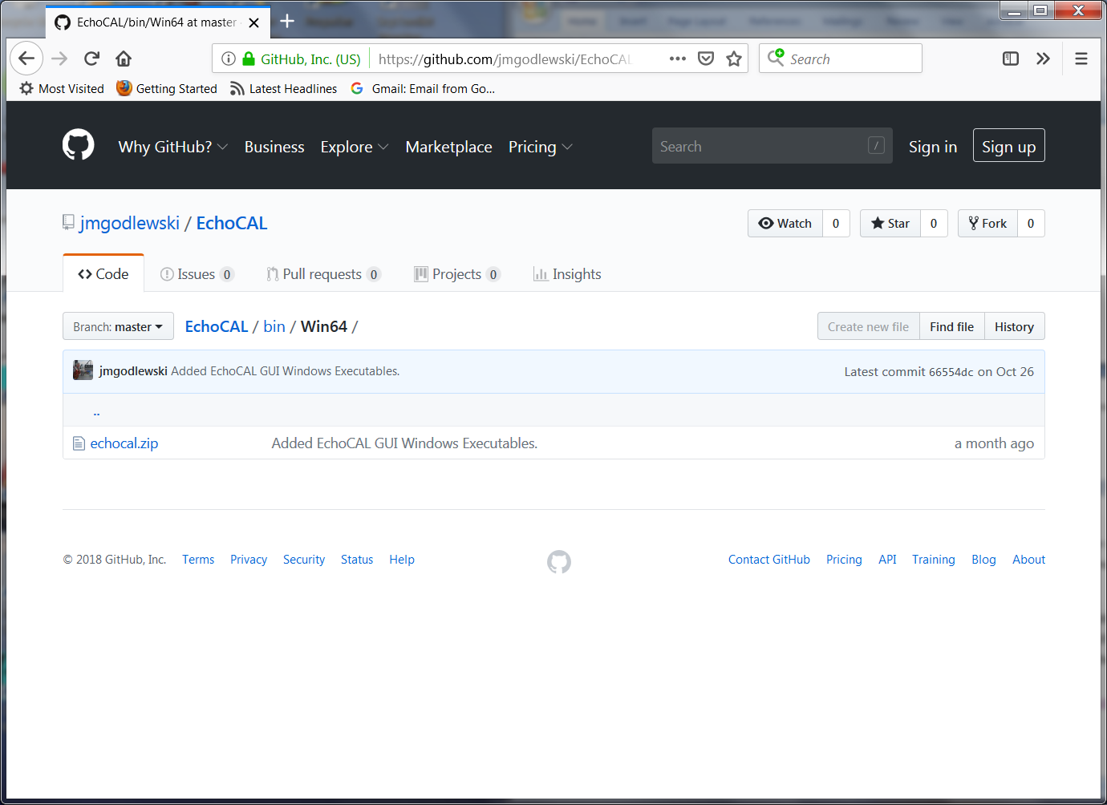

Click on echocal.zip.

Figure 18: EchoCAL GitHub Site: /bin/Win64 Folder

* 1. Click on the “echocal.zip” file in the web browser’s window. A new page will open which will allow you to download the “echocal.zip” file. Select the **Download** button to download the ZIP file to your PC. (Figure 12)   
     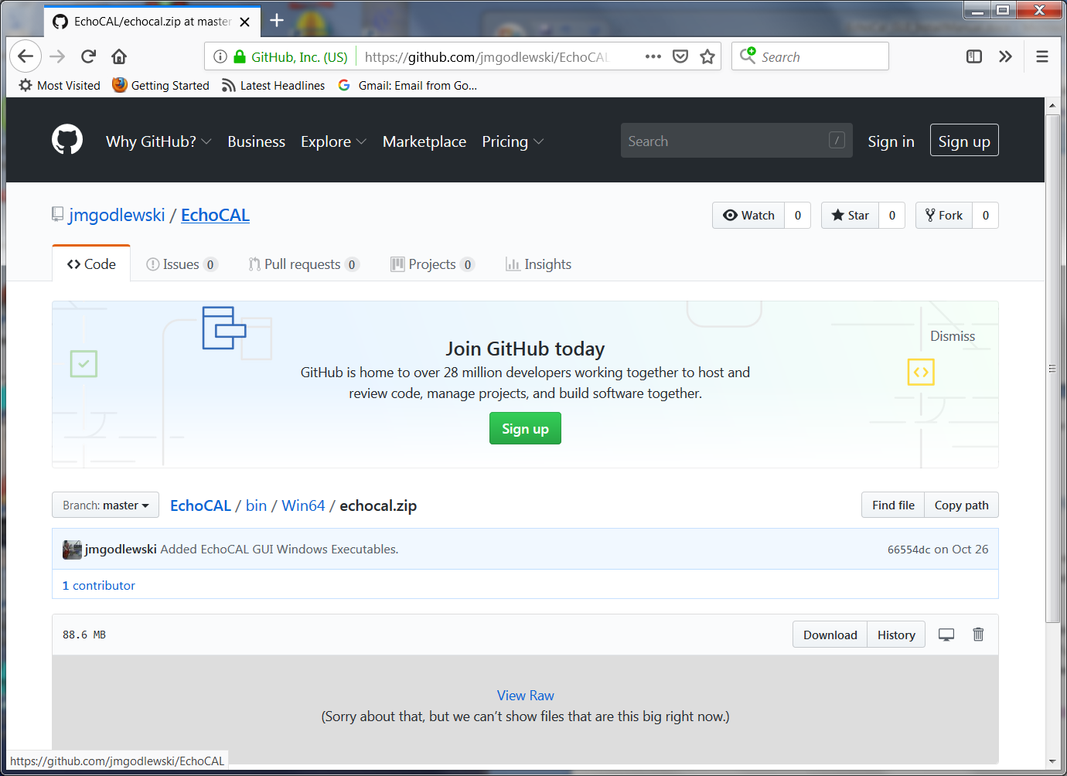

Click Download button.

Figure 19: Download "echocal.zip" file from GitHub.

* 1. When the ZIP file finishes downloading to your PC, navigate to the **Downloads** folder and extract the “echocal.zip” file to a local folder to which the user has write privileges. Figure 13 shows the contents of the ZIP file.  
     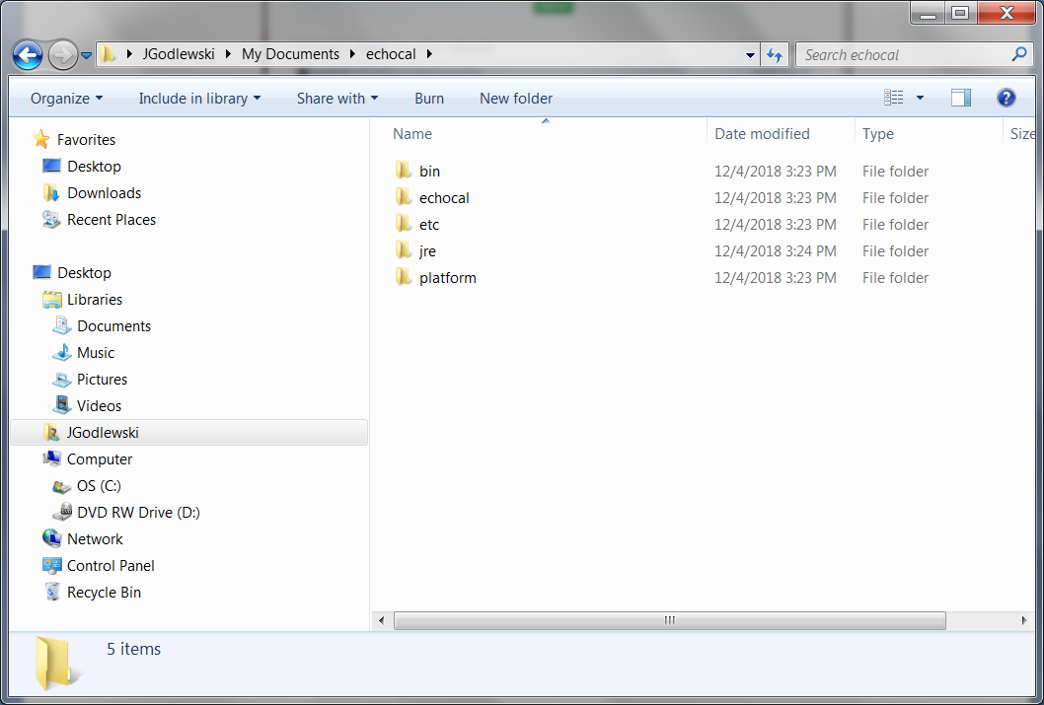

Figure 20. Unzipped EchoCAL folder.

* 1. Navigate to the “**bin**” folder and double-click on the “**echocal64**” executable to launch the *EchoCAL* GUI application. (Figure 14) Note: For the Linux version of the software, use the shell script called “**echocal**” (in the same directory shown alongside the windows executables). Make sure this script is set with proper run permissions on the Linux PC, and double-click the icon to launch the *EchoCAL* GUI.  
     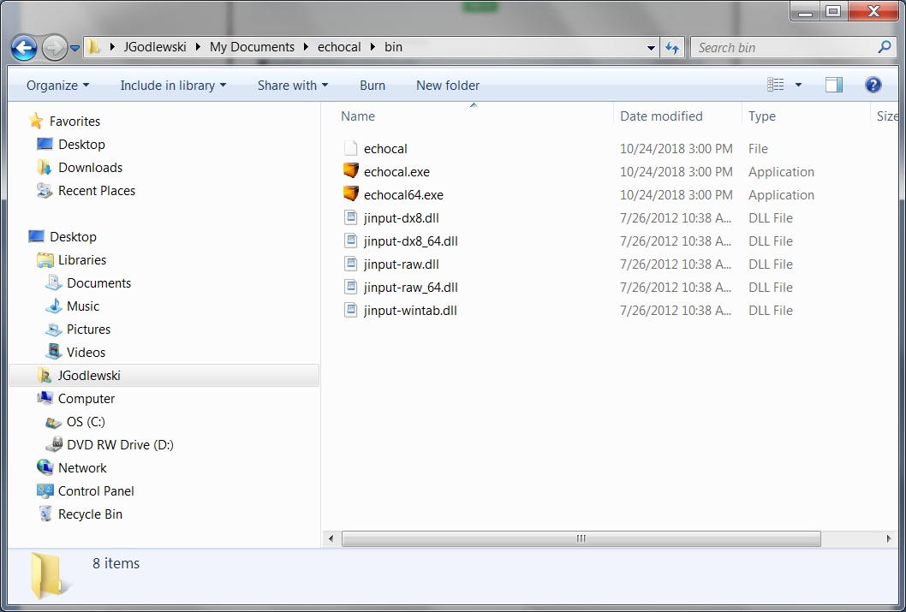

Double-click echocal64.exe to  
launch the EchoCAL GUI app.

Figure 21: EchoCAL Bin folder.

1. See the *EchoCAL* Users Manual for information on how to use the software.

Installing *EchoCAL* Graphical User Interface (GUI) from source code:

The *EchoCAL* Graphical User Interface (GUI) is a JAVA based application which was developed using the Netbeans IDE 8.1 (<https://netbeans.org>) and JAVA JDK 1.8 (64 bit) from Oracle (<https://www.oracle.com/technetwork/java/javase/downloads/index.html>). Prior to downloading the *EchoCAL* source files, install both the latest Netbeans IDE and the JAVA JDK to your PC according to developers’ instructions. Once the JAVA development environment is installed, perform the following steps to setup the *EchoCAL* project:

1. Download the complete *EchoCAL* project from the *EchoCAL* GitHub site (<https://github.com/jmgodlewski/EchoCAL>) by clicking on the green “Clone or download” button in the main EchoCAL GitHub window. (Figure 15)

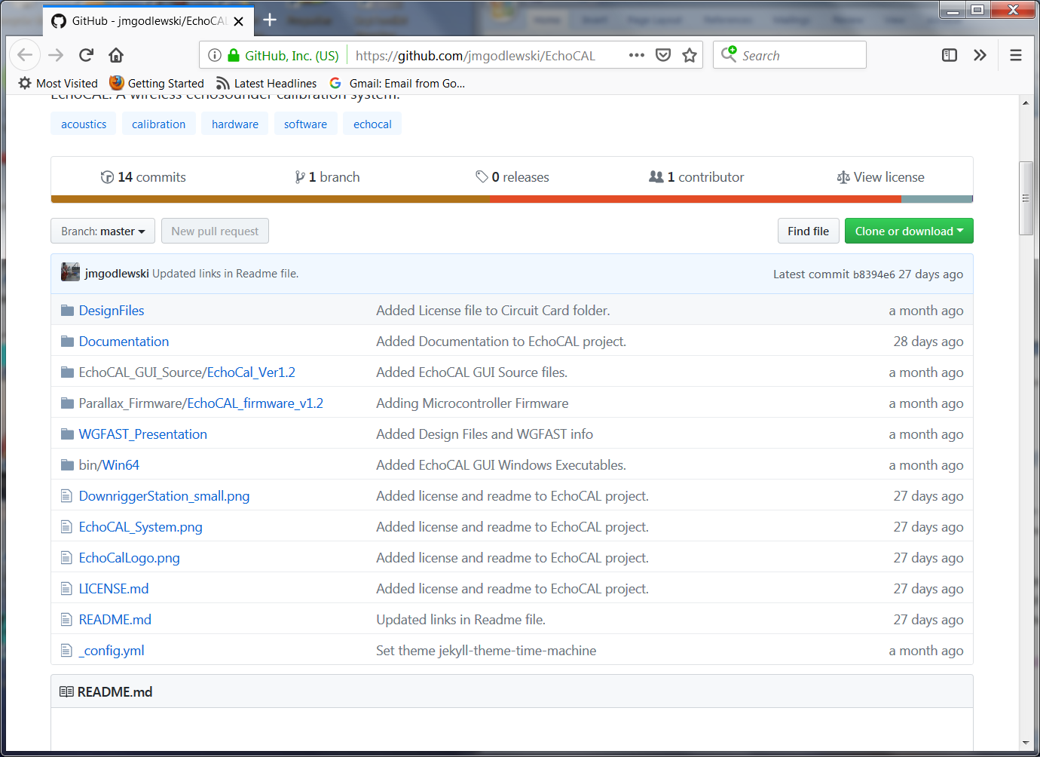

Figure 22: EchoCAL main GitHub project folder.

1. Select the “**Download ZIP**” option to download a ZIP archive of the complete *EchoCAL* project. Extract all files from the “**EchoCAL-master**” ZIP archive to a folder that the user has read/write access to.
2. The *EchoCAL* GUI application uses a third party module called **RXTX,** which provides an interface to the serial ports of a PC. Libraries for **RXTX** must be copied into the local JAVA JDK folder so that the GUI application can make use of the **RXTX** serial port modules. This can be done by performing the following steps:
   1. Navigate to the folder “**EchoCAL-master/EchoCAL_GUI_Source/EchoCAL_Ver1.2/EchoCalCustonFiles**”. (Figure 16)  
      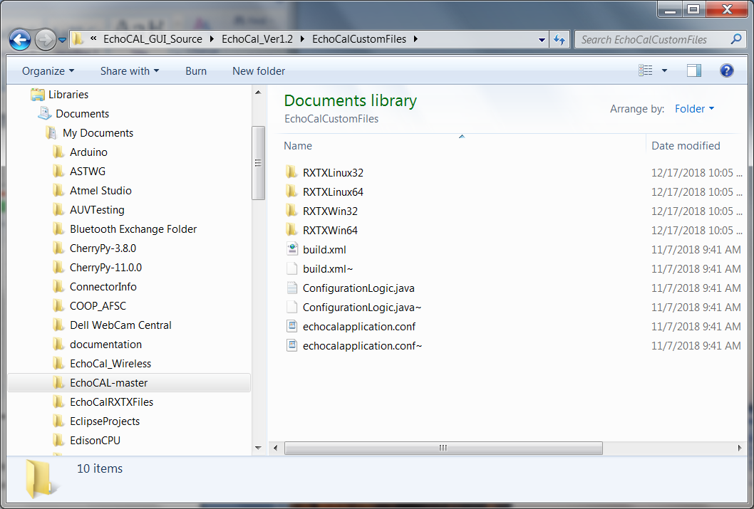

Figure 23: “EchoCalCustomFiles” folder contents.

* 1. This folder contains RXTX modules for the Linux and Windows operating systems, both 32- and 64-bit versions. Select the version that will work for your current operating system. For a Windows 64-bit OS, open the **RXTXWin64** folder to access the RXTX modules for that operating system. (Figure 17)  
     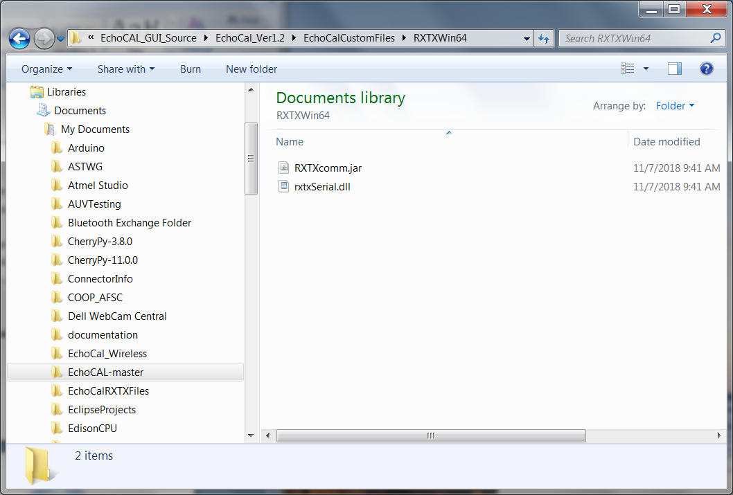

Figure 24: "RXTXWin64" folder contents.

* 1. Copy the “**rxtxSerial.dll**” file to the PCs local JAVA JDK folder. For example, the file should be copied to “**C:/ProgramFiles/Java/jdk1.8.0_101/jre/bin**” for Windows JAVA JDK version 1.8.0.101. (Figure 18)  
     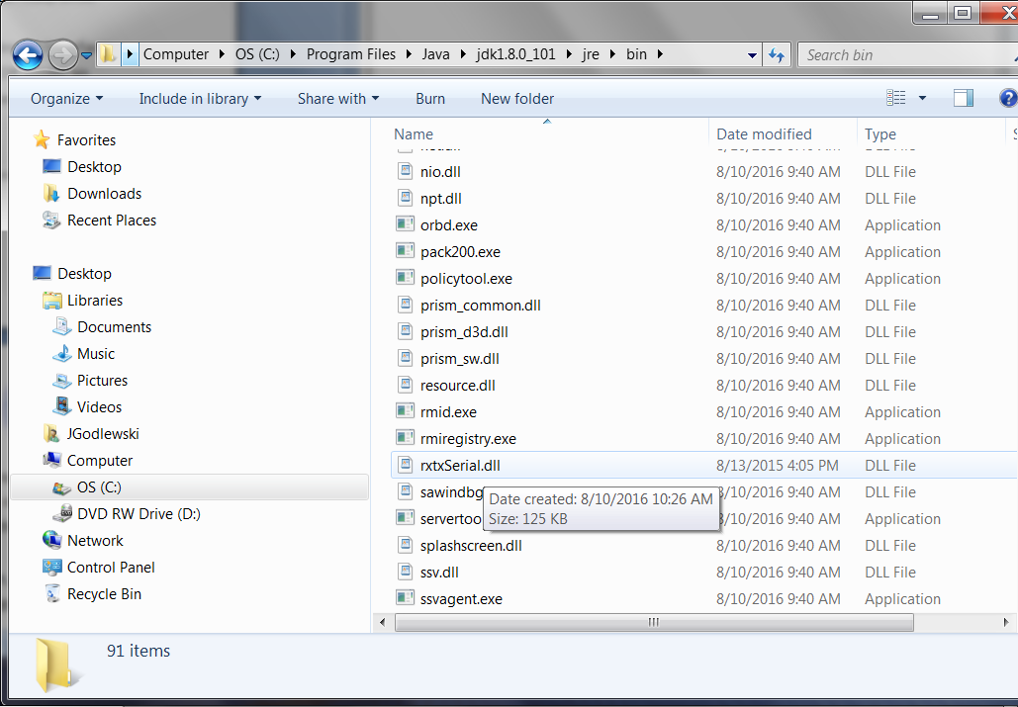

Figure 25: Local JAVA JDK folder for rxtxSerial.dll file.

* 1. Copy the “**RXTXcomm.jar**” file to the “**C:/ProgramFiles/Java/jdk1.8.0_101/jre/lib/ext**” folder. (Figure 19)

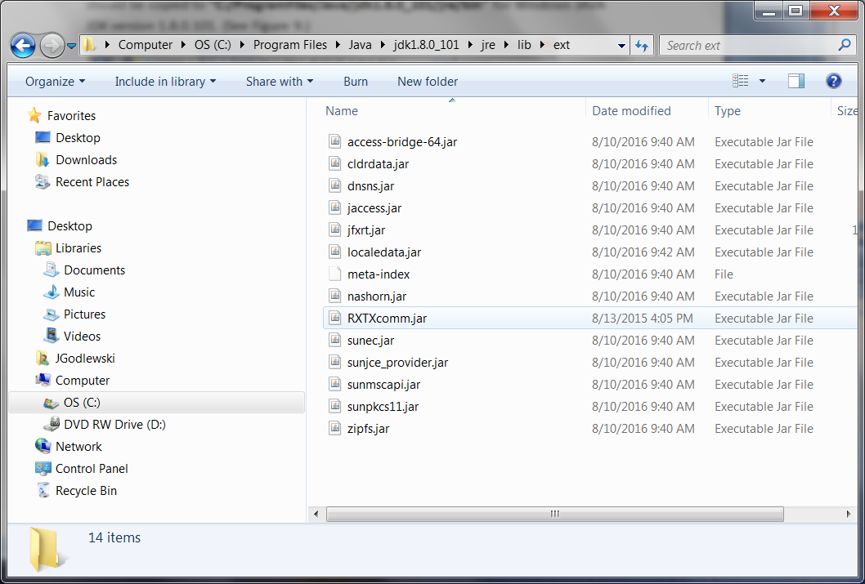

Figure 26: Local JAVA JDK folder for RXTXcomm.jar file.

1. Launch the Netbeans IDE. From the main Netbeans IDE window, select “**File/Open Project**” menu item to open the *EchoCAL* GUI project. (Figure 20)

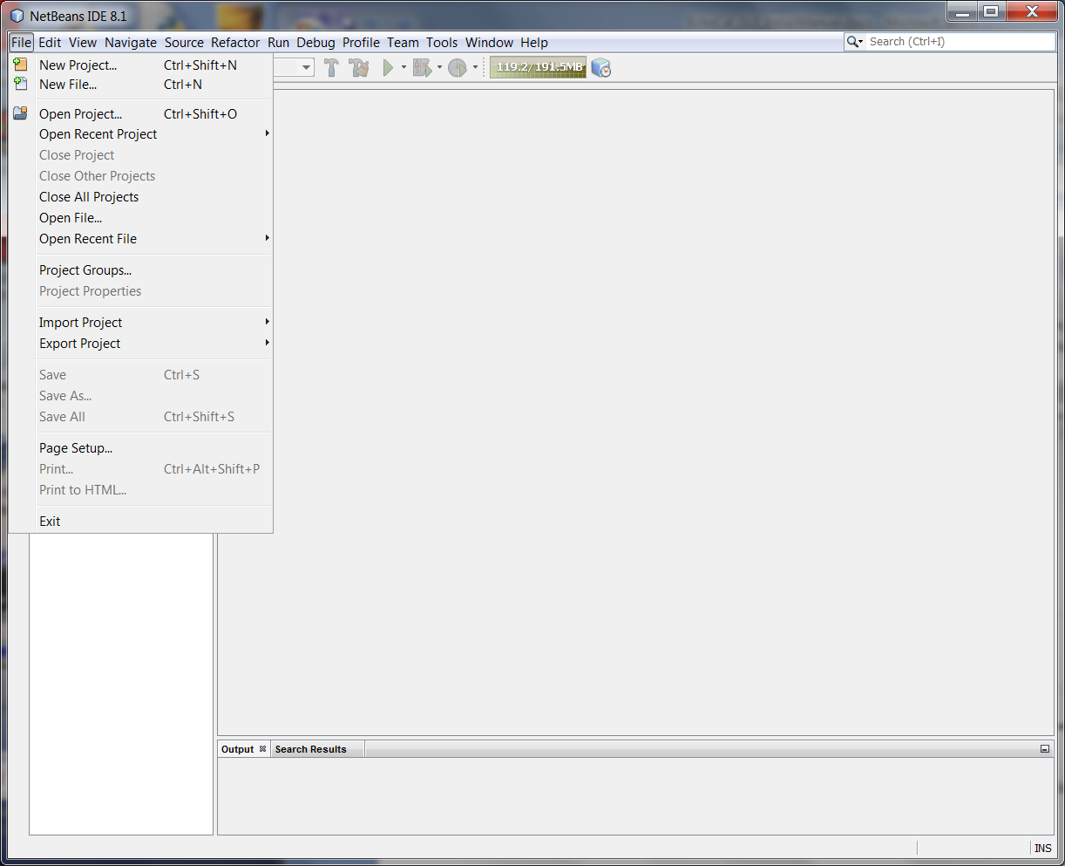

Open Project menu item.

Figure 27: Open Project menu item.

1. The **Open Project** dialog box will open. Browse to the “**EchoCAL-master/EchoCAL_GUI_Source**” folder and select the “**EchoCal_Ver1.2**” project. (Figure 21)

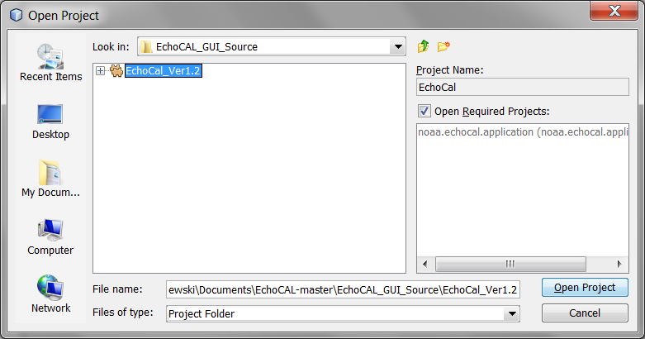

Figure 28: Open Project Dialog Box.

1. Click on the **Open Project** button. The *EchoCAL* GUI project will open in the main Netbeans window. (Figure 22)

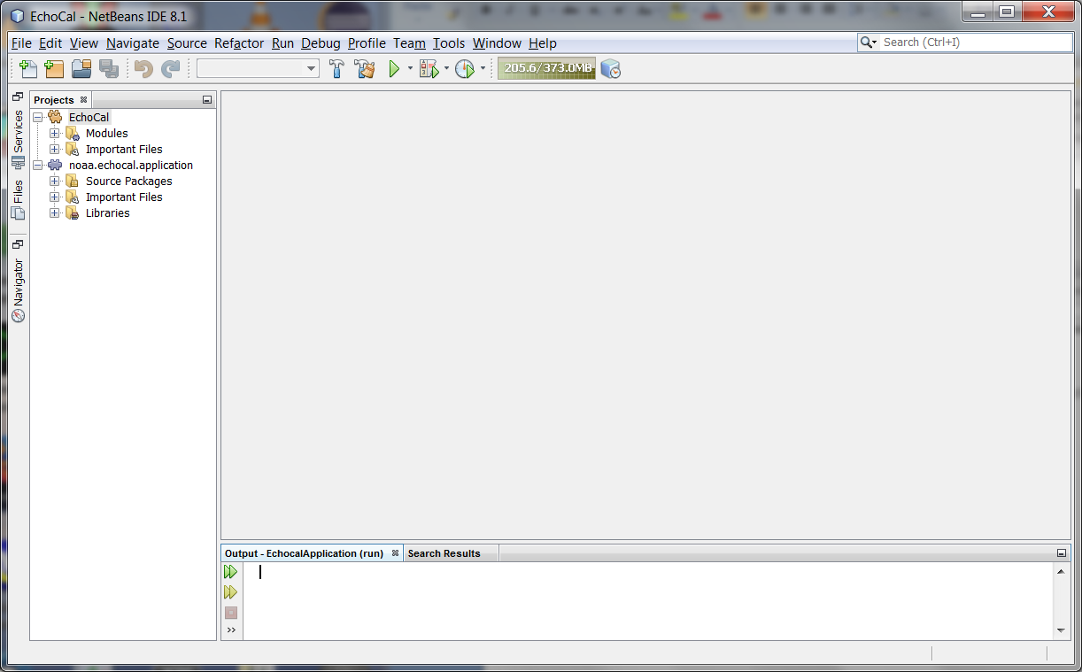

Clean & Build button.

Run Project button.

Figure 29: EchoCAL Project Main Window.

1. Select the “**Clean and Build Project**” button in the toolbar to compile and clean the project. To run the application, select the “**Run Project**” toolbar button. (See Figure 13.) This will launch the *EchoCAL* GUI application.
2. See the *EchoCAL* GUI description (section X.C:) for details on using the *EchoCAL* software.

Creating *EchoCAL* executable from *EchoCAL* Graphical User Interface (GUI) source code:

The Netbeans Integrated Development Environment (IDE) can create executable packages that the user can run independent of the Netbeans IDE. The *EchoCAL* GUI application should be packaged as a “**ZIP**” distribution so that the software can be ported to other PCs that do not have the Netbeans IDE or JAVA installed. To create the *EchoCAL* GUI application, perform the following steps:

1. Make all software changes and test the application as shown in **Section 3** of this document.
2. In the main Netbeans Project window, right-click on the **EchoCal** module in the **Projects** tab portion of the main window and select **Package as**/**ZIP Distribution** (Figure 23).

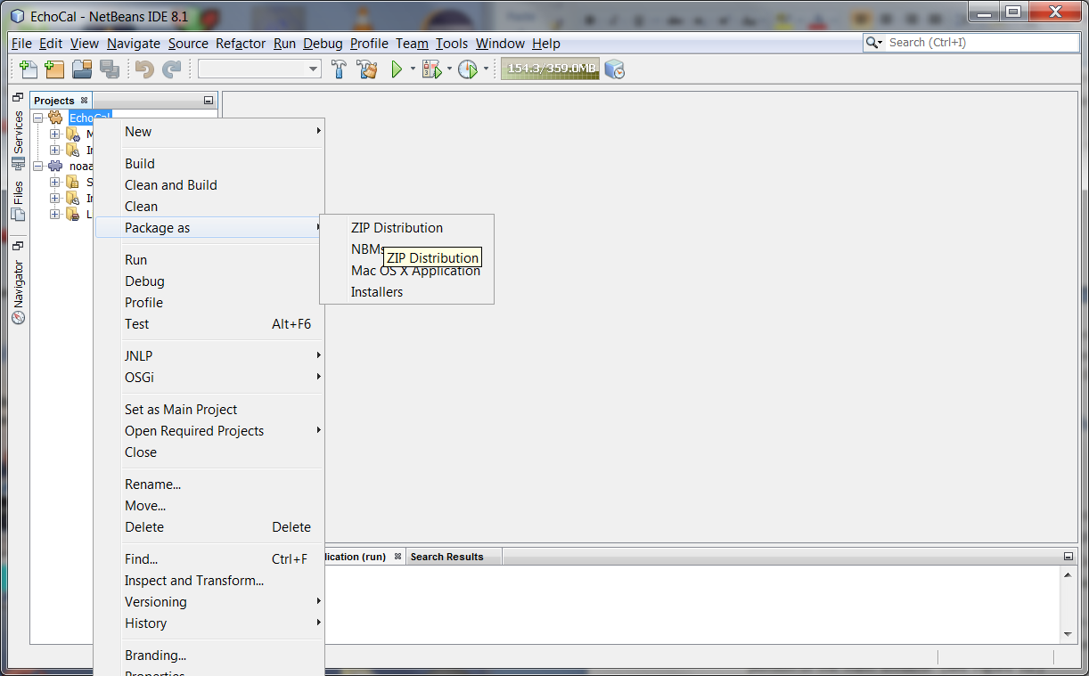

Figure 30: Packaging EchoCAL as a ZIP distribution.

1. The *EchoCAL* GUI application will be packaged as a ZIP file which can then be extracted at a later time. At this point, the GUI application does not have a JAVA Runtime Environment (JRE) packaged with it. It is a good idea to package the JRE with the application so that it can be installed on user PCs without the need to install a separate JAVA JRE on the PC. To add the JRE to the ZIP package, assuming that the developer is using a Windows machine, perform the following steps: (Note: Steps should be similar in a Linux OS as well.)
   1. In Windows Explorer, navigate to the Java Development kit (JDK) that was used to develop the application. In this example, navigate to the “**C:/ProgramFiles/Java/jdk1.8.0_101/**” (Figure 24).

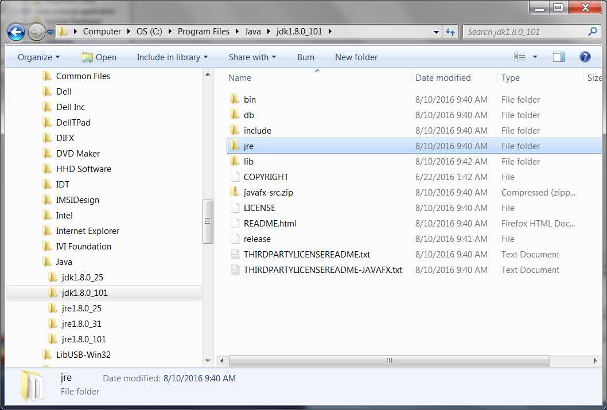

Figure 31: Java Development Kit (JDK) Folder.

* 1. Right-Click on the “**jre**” folder and select “**Copy**”.
  2. Navigate back to the “**EchoCAL-master/EchoCAL_GUI_Source/EchoCAL_Ver1.2/**” project folder. When Netbeans created the ZIP distribution of the *EchoCAL* GUI, it created a new “**dist**” folder in the main project folder (Figure 25). This folder contains the “**echocal.zip**” application file.

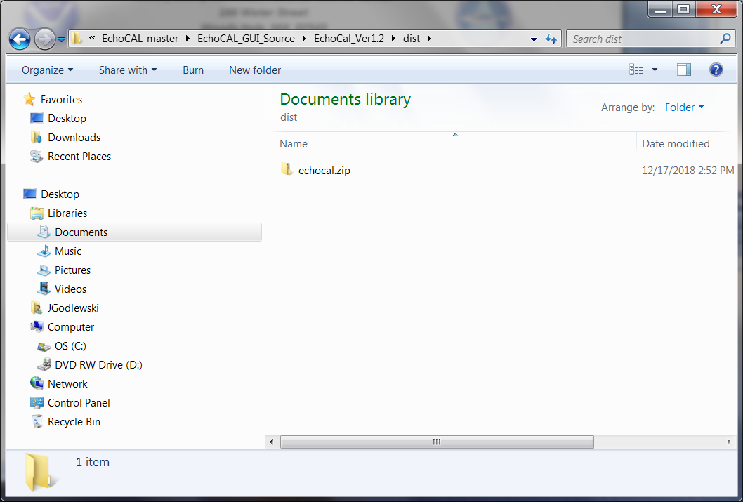

Figure 32: ZIP Distribution Folder for EchoCAL.

* 1. In Windows Explorer, double-click on the “**echocal.zip**” file to open the ZIP file in an Explorer window. Double-Click on the “**echocal**” folder to open the application folder (Figure 26).

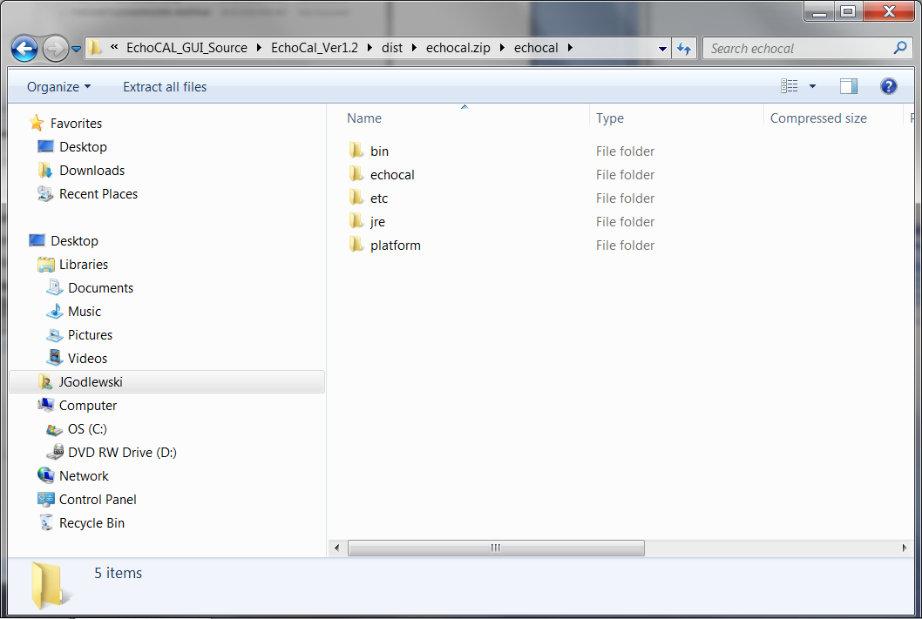

Figure 33: New JRE folder inside "echocal.zip" file.

* 1. Right-Click in this window, and select “**Paste**” from the contextual menu. The JRE folder will be compressed/copied into the “**echocal.zip**” distribution file (Figure 26).

1. Now that the JAVA Runtime Environment has been copied into the *EchoCAL* GUI distribution package, we now need to copy the Dynamic Link Libraries (DLLs) for the USB Joystick functionality. Navigate to the “**EchoCAL-master/EchoCAL_GUI_Source/EchoCAL_Ver1.2/jinput**” folder. Select the following DLLs: **jinput-dx8.dll**; **jinput-dx8_64.dll**; **jinput-raw.dll**; **jinput-raw_64.dll**; and **jinput-wintab.dll**. Right-Click on the files, and select “**Copy**” (Figure 27). (Note: If the ZIP package was developed in Linux, copy the files **libjinput-linux.so** and **libjinput-linux64.so**.)

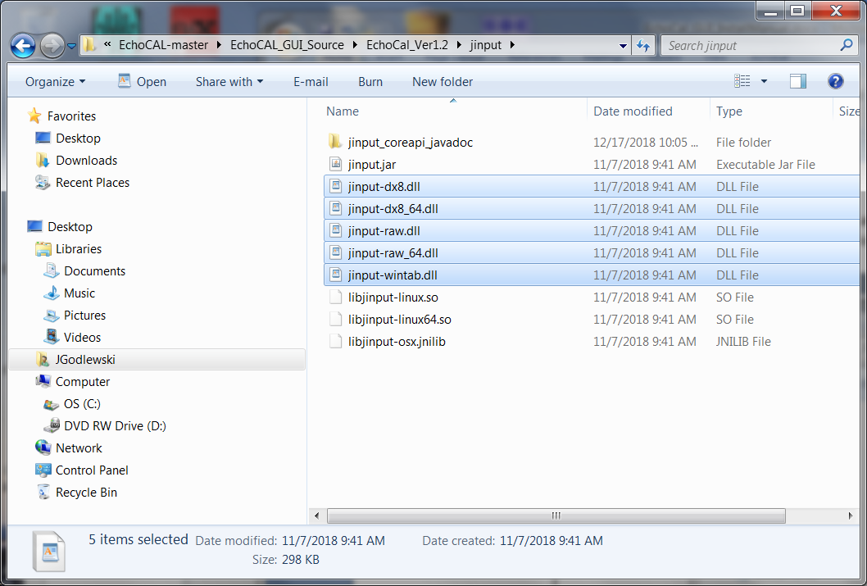

Figure 34: JInput Dynamic Link Libraries.

1. Next, navigate to the “**EchoCAL-master/EchoCAL_GUI_Source/EchoCAL_Ver1.2/dist/echocal.zip/echocal/bin**” folder. Right-click in the folder and select “**Paste**”. This will add the libraries to the **EchoCAL** executable folder for use by the application (Figure 28).

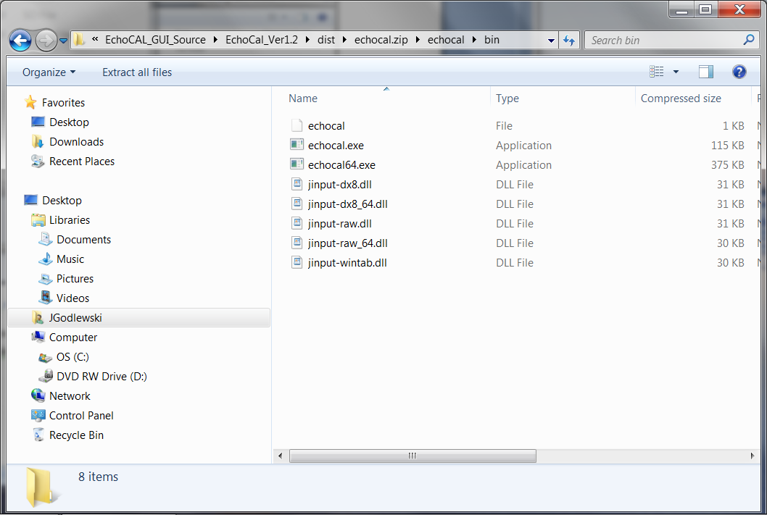

Figure 35: DLLs copied to ZIP distribution folder.

1. At this point, the *EchoCAL* ZIP distribution package is ready for deployment.

## EchoCal Wireless Network and XCTU

**EchoCAL ZigBee Wireless Network:**

**Monitoring Network Signal Strength using DigiKey “XCTU” software.**

1. 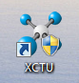A special software package developed by Digi International called “XCTU” is used to monitor the signal strength on the EchoCAL wireless network. This program allows the operator to visually see the signal strengths of all nodes in the ZigBee wireless mesh network.
2. Plug the EchoCAL Base Station into the PCs USB port. Verify which COM port is assigned to this base station using Window’s Device Manager.
3. 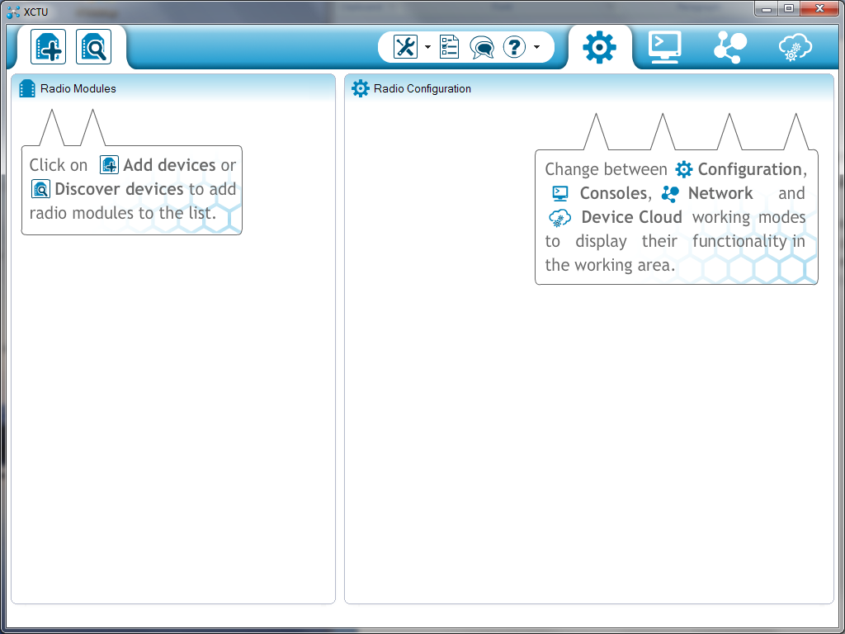Launch the XCTU software by double-clicking the XCTU icon on the PCs desktop. The XCTU main window will open on the PC (Figure 29).

Discover Devices Tool

Figure 36: XCTU main window.

1. 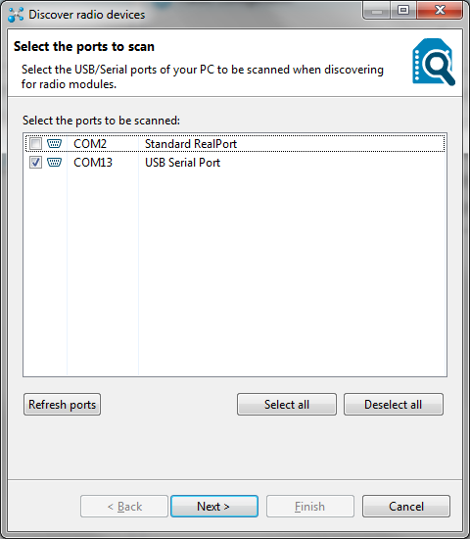Click on the “Discover devices” tool icon on the top left portion of the XCTU window. This tool allows the software to automatically locate ZigBee transceivers attached to the PC. At this point, the “Discover radio devices” window will open (Figure 30). Select the checkbox next to the COM port that the EchoCAL Base Station is attached to. Click on the “Next” button at the bottom of the window to continue.

Figure 37: Discovery radio devices window.

1. The “Set port parameters” window will open. Verify that the Serial/USB port parameters are properly configured:

* Baud Rate: 9600,
* Data Bits : 8,
* Parity: None,
* Stop Bits: 1,
* Flow Control: None.

1. 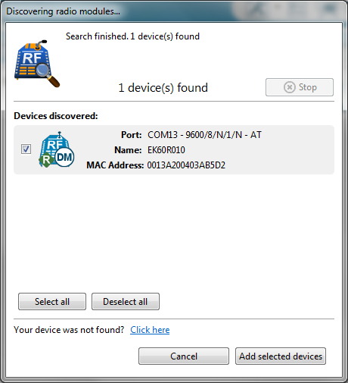Click on the “Finish” button to continue. A new window will open which will show the device discovered on the PCs COM port. When the device appears on the “Devices discovered” portion of the window, verify that the correct device has been identified (Figure 31). Note: The devices name should be “EK60R010”. Once the device appears, select the “Add selected devices” button to select the base station transceiver.

Figure 38: Discovering radio modules window.

1. The selected transceiver will appear in the main XCTU window in the left column. Click on this device, and the transceiver’s parameters will begin loading on the right side of window (Figure 32). Using the scroll bar on the right side of the window, scroll down the parameter list until you get to the **“Serial Interfacing”** portion of the transceiver’s parameter list. Locate the **“AP API Enable”** parameter under the Serial Interfacing section. In normal EchoCAL operation, this parameter should be set to **“Transparent Mode [0]”**. Click on this parameter to change the setting to **“API without escapes [1]”**. This parameter will turn GREEN, indicating that a change was made to this parameter. Click on the red **“Pencil”** icon to the right of this parameter to save it to the transceiver. Once the **“Pencil”** icon is selected, the change will be written to the transceiver, and the parameter will turn BLUE in the window. This change needs to be made to allow the transceiver to query other devices on the network about their configuration settings. Information about these modes can be found on page 47, “Serial Modes” of the XBee®-PRO 900HP/XSC RF Modules S3 and S3B User Guide.

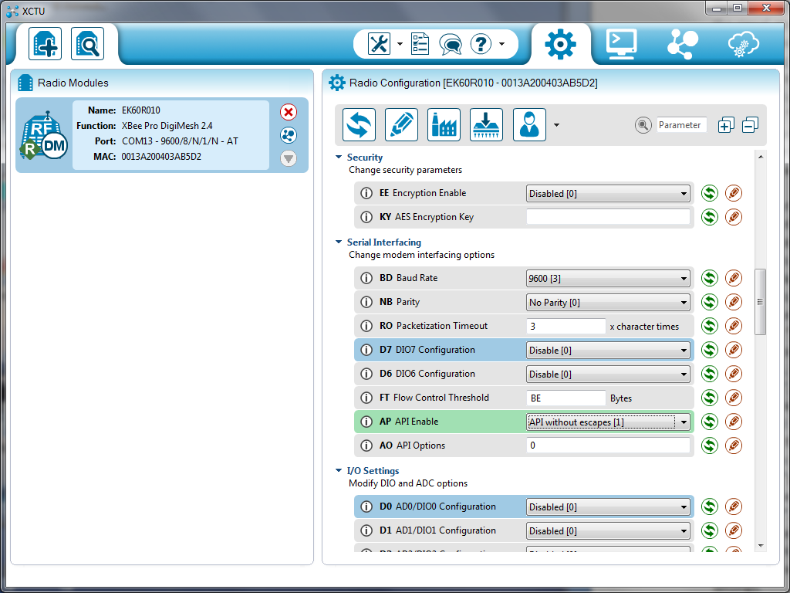Once the “AP API Enable” parameter has been changed, select the “Discover radio nodes in the same network” icon on the EK60R010 display on the left side of the main program window. This action will launch a new “Discovering remote devices” window (Figure 33), and the software will begin scanning the local wireless network for the various nodes that are available on the mesh network. Make sure all of the installed devices appear on the “New remote devices discovered” portion of this window. When all devices appear in this window, click on the **“Add selected devices”** button. This window will close, and the selected devices will appear below the base stations entry on the left column in the main XCTU window.

Discover radio nodes in same network icon:

Figure 39: Radio configuration.

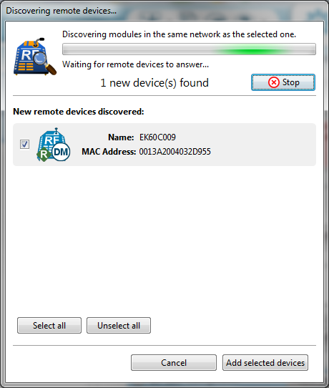

Figure 40: Discover remote devices window.

1. In the main XCTU window, select the “Switch to Networking Mode” tool icon on the right upper tool bar in the main window. The lower right portion will change to a tabbed interface showing the EK60R010 base station in the tab’s label (Figure 34).
2. 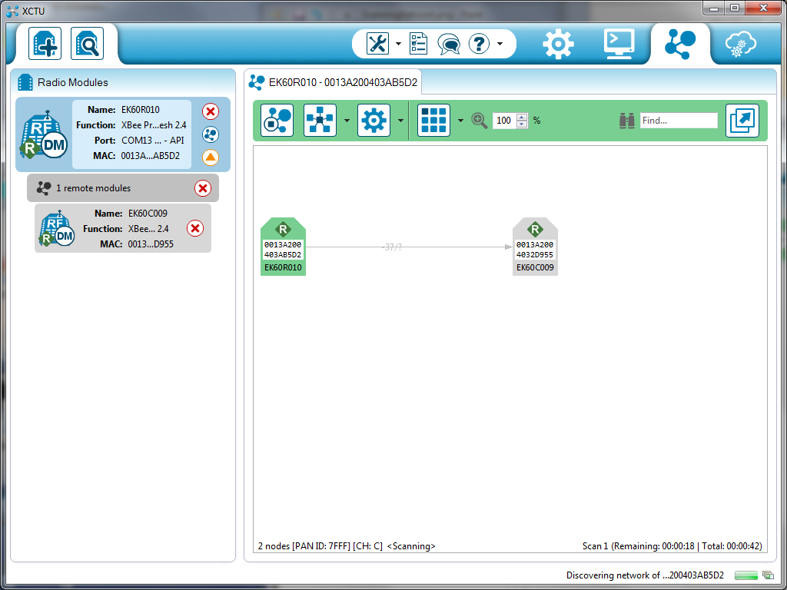In the tab toolbar portion of the window, select the “Start scanning the radio module network” tool. The lower portion of the tab window will show the EK60R010 graphic which symbolizes the EchoCAL base station. All other transceivers on the network will begin appearing, with links between different transceivers that show the transmit/receive signal power levels. Verify that all of the transceivers appear, and that there is a sufficient transmission path between all transceivers in the network. When satisfied with the performance, select the “Stop scanning the radio module network” tool in the tab’s toolbar (Figure 34).

Figure 41: Wireless network display.

Start/Stop scanning the radio module network.

1. Return the system to transparent mode for operation with EchoCal. Select the “Switch to Configuration working mode” toolbar in the main window to bring up the parameter settings for the EK60R010 base station. Using the scroll bar on the right side of the window, scroll down the parameter list until you get to the **“Serial Interfacing”** portion of the transceiver’s parameter list. Locate the **“AP API Enable”** parameter under the Serial Interfacing section. Click on this parameter to change the setting back to **“Transparent Mode [0]”** (Figure 35). This parameter will turn GREEN, indicating that a change was made to this parameter. Click on the red **“Pencil”** icon to the right of this parameter to save it to the transceiver. Once the **“Pencil”** icon is selected, the change will be written to the transceiver, and the parameter will turn BLUE in the window. **This change needs to be made to allow the transceiver to act as a serial line replacement to the downriggers.** Information about these modes can be found on page 47, “Serial Modes” of the XBee®-PRO 900HP/XSC RF Modules S3 and S3B User Guide.

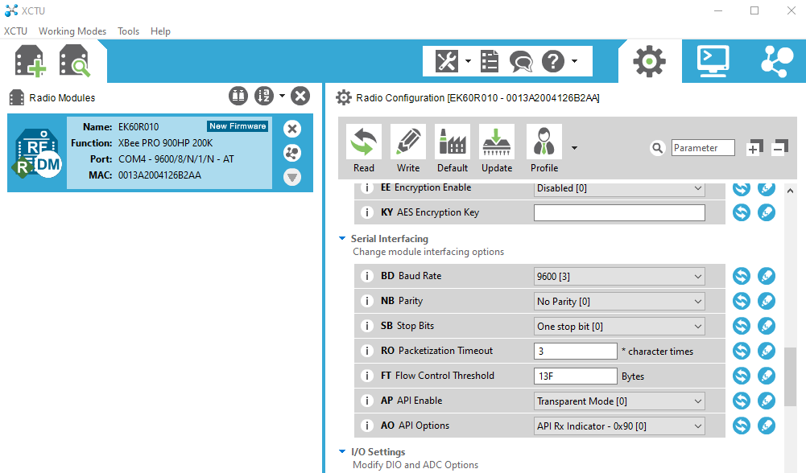

Figure 42: AP mode setting.

1. Click on the red X icon on the base station graphic to close the COM port to the base station. Close the XCTU program.

## Tenergy batteries and charger information

When routers are plugged into the chargers, set charger to 1A (if there is a choice) and monitor the LED on the charger and the temperature of the router box while charging.

The routers are powered by rechargeable NiMH battery packs:

* Tenergy 12V 2000 mAh NiMH with bare leads, P/N 11606
* Tenergy Smart Universal Charger for NiMH/NiCD Battery Packs: 6v-12v, P/N 01025 (black)
* Tenergy Smart Universal Charger for NiMH/NiCD Battery Packs: up to 6v, discontinued (green)

The following information has been adapted from Tenergy’s 6v-12v charger user manual (in case it is misplaced):

The newer black chargers are multi-current Universal Fast and Smart Charger for any NiMH/NiCd battery packs from 6V-12V (5- 10 cell pack) with capacity between 1000mAh and 9000mAh, 100-240V AC input for worldwide use.

* The charger will automatically detect battery pack's voltage:
  + When the charger is connected to the power outlet, the red and green LEDs will each flash once.
  + Green LED will flash slowly when no battery is plugged in.
  + Red LED will be on during charging.
  + Green LED will be on when battery is fully charged.
  + Red LED will flash when the charger recognizes the battery as damaged or voltage is below 6V.
  + Both LEDs will be off if short circuit or polarity is reversed.
* The charger will stop charging automatically when the battery is fully charged, or when battery's temperature IS over 60°C (if the temperature probe is affixed to the battery)
* A safety timer will stop charging after operates 5 hours.
* There are two charging current settings (1.0A and 2.0A). selectable by a switch.
  + For battery pack capacities between 1000mAh and 2000mAh, please use the low current level switch (charging rate:1.0A).
  + For battery pack capacities between 2000mAh and 9000mAh, you can choose the high current level switch (charging rate: 2.0A)
* Fast charging time from approx. 70 mins to 21O mins depending on the capacity of battery. For a 5000mAh batter y pack. charging time is about 210 mins (2 A charging current) and for a 2000mAh battery pack. charging time is 150 mms (1.0A charging current).

## Echocal Firmware Installation

**Microcontroller Firmware Installation**

Introduction

The *EchoCAL* Control Box (Figure 36) uses a custom-built printed circuit board (PCB) which incorporates a ***Parallax Propeller*** microcontroller (<https://www.parallax.com/product/p8x32a-d40>) to interact with the Canon Downriggers as well as provide wireless communications with the controlling PC. This microcontroller is programmed using the ***Propeller Tool*** Integrated Development Environment (IDE) (<https://www.parallax.com/downloads/propeller-tool-software-windows-spin-assembly>). Each *EchoCAL* Control Box requires a unique serial number to allow the *EchoCAL* Graphical User Interface (GUI) software to reliably interact with each downrigger station. The following instructions will tell the user how to program the microcontroller as well as assign a unique serial number to the box.

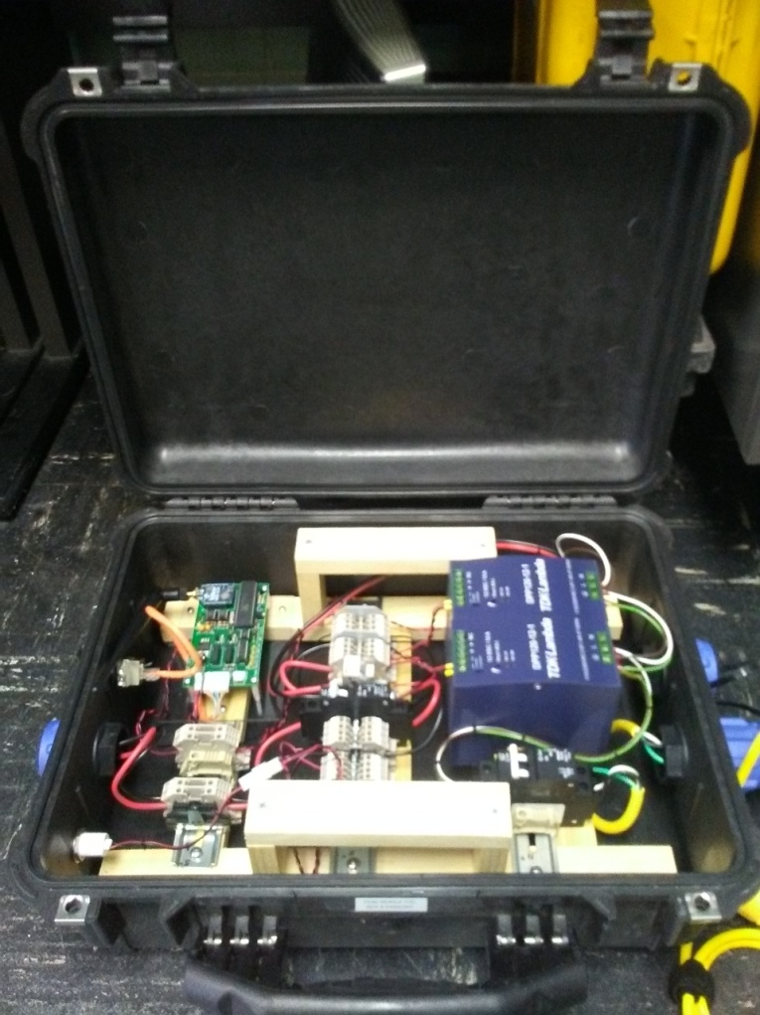

Figure 43: EchoCAL control box assembly.

Installing Microcontroller Firmware:

* Prior to firmware installation, open the *EchoCAL* Control Box, and connect the *EchoCAL* Control Box PCB serial header to a Window’s based PC’s serial port using the **ECHOCAL-10550** Programming cable. (Figure 37)

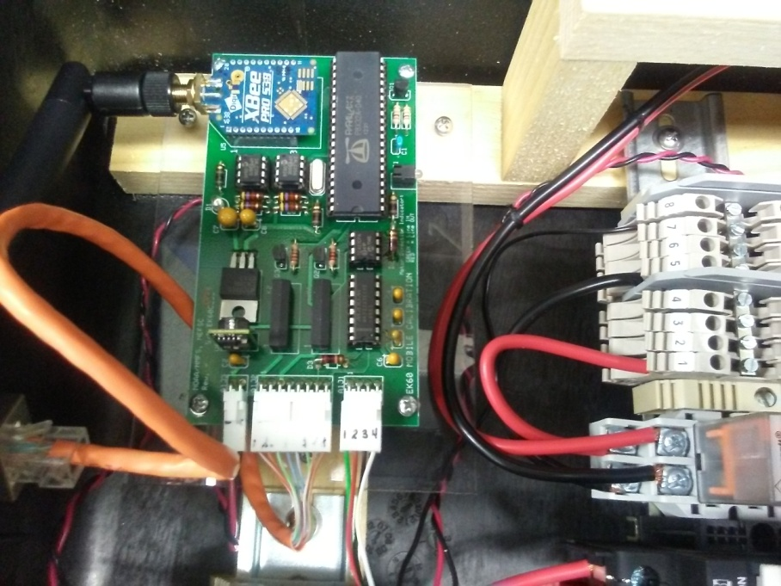

Figure 44: PCB Serial Header Location.

* Connect the **ECHOCAL-10500** AC Power cable to the control box, and plug into a standard AC outlet. Verify that the Red LED light illuminates on the PCB. If not, check that the AC circuit breakers inside the control box are in the ON position.

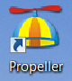(**Warning:** 115 VAC power is applied to the control box at this time. Use caution when handling components inside the control box.)

* Install the Propeller Tool IDE on the PC as per manufacturer’s instructions. Double click on the Propeller Desktop Icon to launch the software.
* The main Propeller Tool window will open. Select **File/Open** menu item to access the “Open” dialog window. Browse to the latest folder location of the *EchoCAL* firmware (…/EchoCAL_firmware_v1.2) and open file “EchoCAL.spin” (Figure 38).

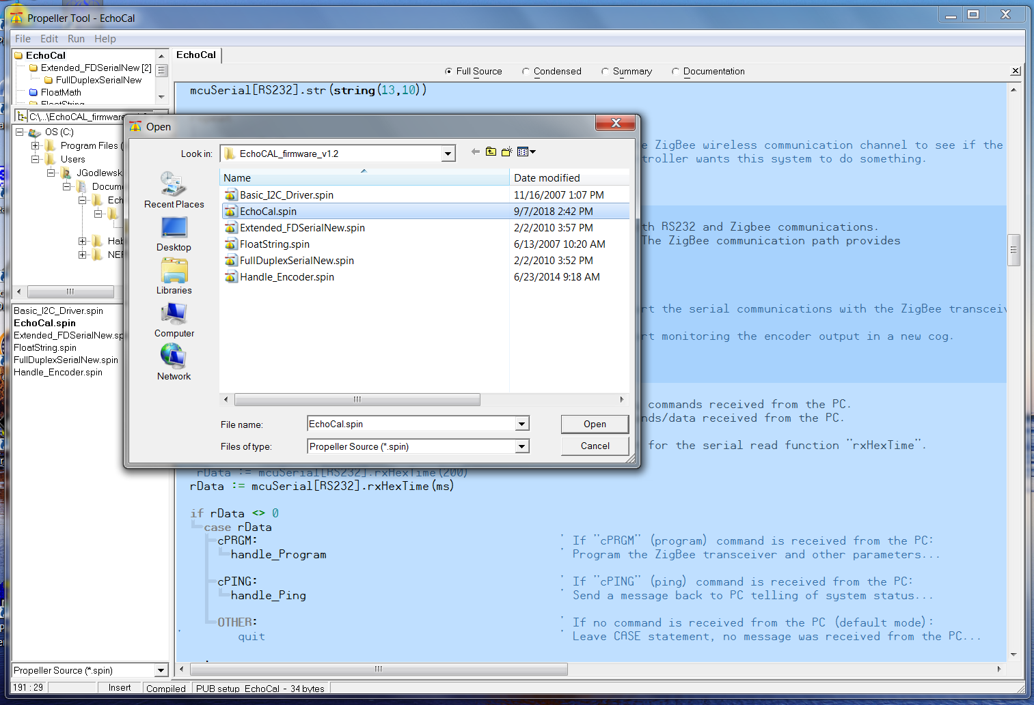

Figure 45: Control box firmware source file selection.

* Select the **Run->Compile Current->Load EEPROM** menu item to install the firmware (Figure 39).

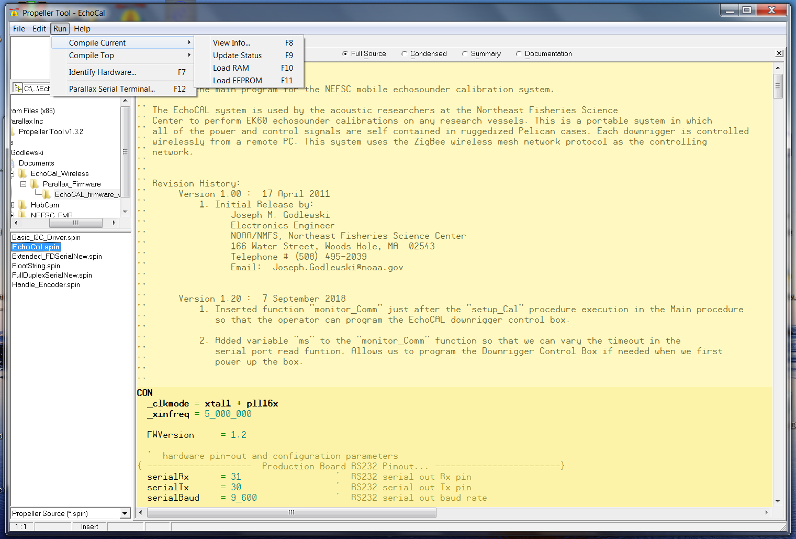

Figure 46: Compiling and uploading control box firmware.

* At this point, the firmware will be loaded in the EEPROM on the PCB. Proceed to the next section to program the *EchoCAL* Control Box serial number.

Programming the *EchoCAL* Control Box Serial Number:

* If power is applied to the *EchoCAL* Control Box, remove power from the device by either unplugging the power cord, or switch the AC circuit breakers to the OFF position.
* Connect the **EchoCAL-10550** Programming Cable from the serial header on the *EchoCAL* Control Box PCB to a spare COM port on any Window’s based PC. (Note: If no COM ports are available, you can use a USB to Serial adapter cable instead.)
* Launch the **Parallax Serial Terminal** (<https://www.parallax.com/downloads/parallax-serial-terminal>) application on the Window’s PC, and open the COM port that *EchoCAL* is attached to. (Serial port parameters should be set to: Baud Rate = 9600 baud, Data Bits = 8 bits, Parity = None, Stop Bits = 1, Flow Control = None.)
* Apply power to the *EchoCAL* Control box and verify that the LED on the PCB is illuminated. (Note: When power is first applied to the PCB, the firmware will slave to the RS232 serial port to wait for programming commands from the user’s PC. The user will have 10 seconds to put the microcontroller into “Programming” mode. After 10 seconds, the microcontroller will start its regular firmware routines.)
* Type the character “**a**” without quotes, and press the return key. You should see a menu similar to the following (Figure 40):

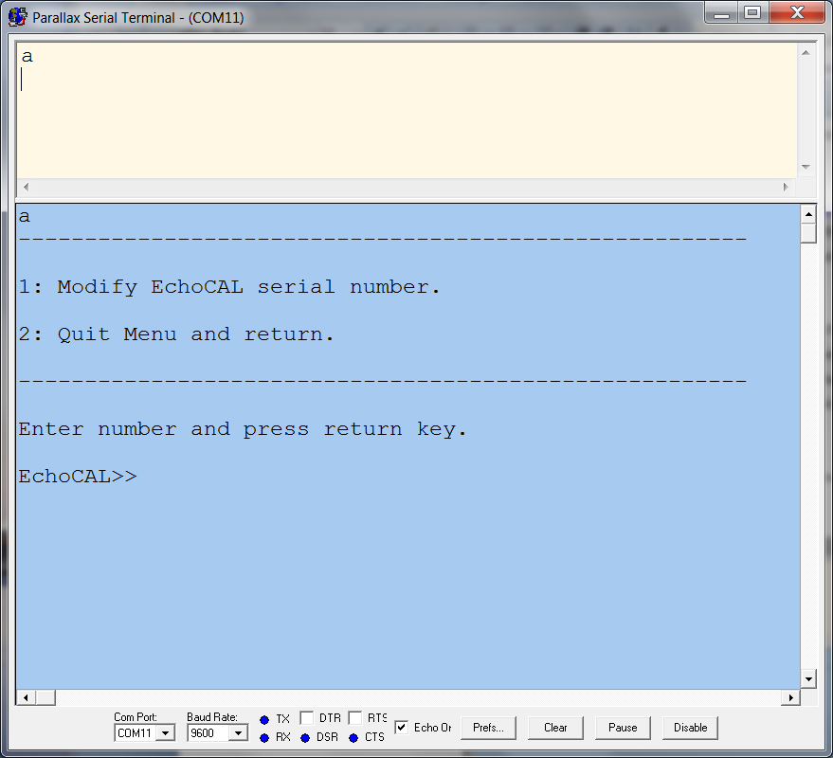

Figure 47: Accessing the microcontroller programming menu.

* Select menu item “1” and press the return key. A new menu should be displayed allowing the user to change the *EchoCAL* Control Box serial number (Figure 41).

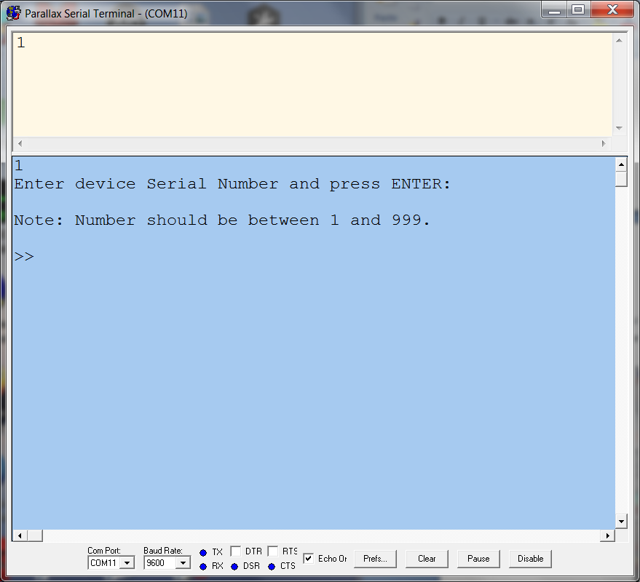

Figure 48: Entering a new control box serial number.

* Enter the serial number for the control box. The integer number should be from 1 to 999. Press return key to continue. (Notice that the serial number will be prefaced with the characters “EK60C”. The *EchoCAL* Graphical User Interface (GUI) uses this serial number representation to determine which downrigger to talk to. This step will also change the Node ID of the ZigBee Pro wireless transceiver to the same serial number as the control box.)
* Once the serial number has been changed, select menu item “2” to exit the Modify Serial Number menu (Figure 42). The control box’s serial number should now be changed. At this point, the *EchoCAL* Control Box should be ready for echosounder calibration activities.

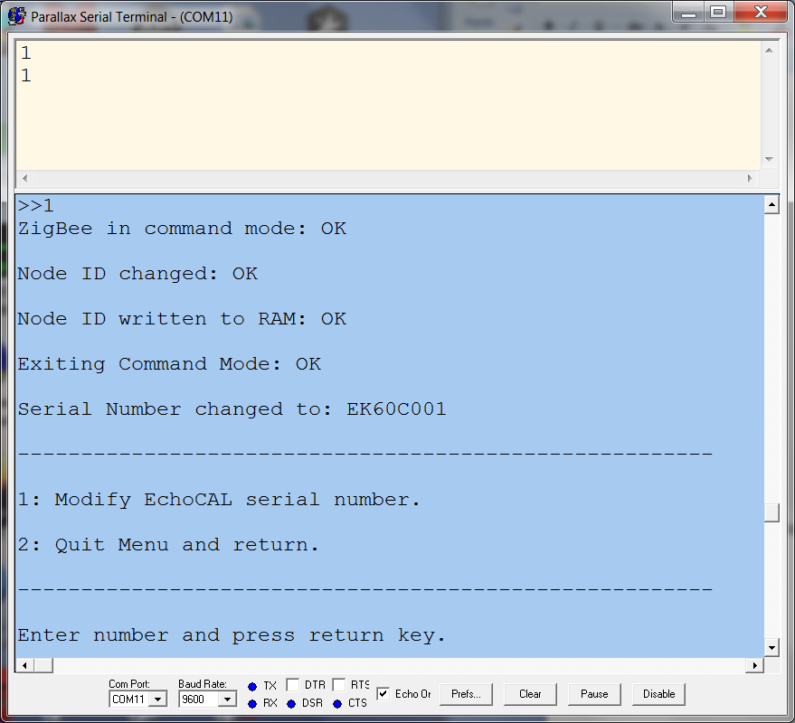

Figure 49: Exiting the programming menu.

# Bibliography

Foote, K. G. (1984). "Comparison of copper and tungsten carbide calibration spheres." J. Acoust. Soc. Am. **75**(2): 5.

Foote, K. G. K., H. P.; Vestnes, G.; MacLennan, D. N. and Simmonds, E. J. (1987). "Calibration of acoustic instruments for fish density estimation: A practical guide. Int. Coun. Explor." Sea Coop. Res. Rep. **144**: 1-69.

MacLennan, D. N. and I. Svellingen (1989). "Simple calibration technique for the split-beam echo-sounder."